Module ICT3715

INFORMATION AND COMMUNICATION TECHNOLOGY PROJECT

|  |  |  |  |  |  |  |  |  |  |
| --- | --- | --- | --- | --- | --- | --- | --- | --- | --- |
| STUDENT NUMBER (Student completes) | | | | | | | | | |
| **6** | **5** | **6** | **1** | **4** | **9** | **6** | **8** | **-** | **-** |

|  |  |  |  |  |  |  |  |  |  |  |  |  |
| --- | --- | --- | --- | --- | --- | --- | --- | --- | --- | --- | --- | --- |
| IDENTITY NUMBER (Student completes) | | | | | | | | | | | | |
| **9** | **3** | **0** | **2** | **2** | **4** | **5** | **0** | **5** | **3** | **0** | **8** | **8** |

No handwritten assignments will be accepted.

**INSTRUCTIONS:**

Complete this Front Page (page 1)

Complete the Plagiarism Pledge (page 2)

Complete the header and footer with your own information

Add your practical system content to the document

Remove everything that is in brackets []

Make sure that your Table of Content is updated

Save the document as a MS Word Document, e.g., 12345678\_ICT3715\_Portfolio (replace 1234568 with your student number)

When you are done submit via myModules 2022 on the Module Site under Project Portfolio Document

Keep a copy of the original should there be problem with the upload

PLAGIARISM PLEDGE BY THE STUDENT

1. I have read Unisa’s plagiarism policy.
2. I understand Unisa’s plagiarism policy.
3. I agree to abide by Unisa’s plagiarism policy.
4. I have read the direct copying, plagiarism, and “patch-writing” document.
5. I understand what direct copying, plagiarism, and “patch-writing” is.
6. I undertake to avoid copying directly, plagiarism and patch writing.
7. All academic work, written or otherwise, that I submit is expected to be the result of my own skill and labour.
8. I understand that, if I am guilty of the infringement of breach of copyright/plagiarism or unethical practice, I will be subject to the applicable disciplinary code as determined by Unisa.
9. The marker has the right to refuse to assess the assignment and the system if plagiarism is detected.

Student name and Surname: \_\_\_\_\_\_Ralph Botes\_\_\_\_\_\_\_\_\_\_\_

Student number: \_\_\_\_\_65614968\_\_\_\_\_\_\_\_\_\_\_\_\_



\_\_\_\_\_\_\_\_\_\_\_\_\_\_\_\_\_\_\_\_\_\_\_\_\_\_\_ 05-10-2022

Student signature: Date:

**System | Online examination file submission system**

Due to the pandemic, the University of South Africa (UNISA) has decided to **conduct all examinations in an online environment.**

The **purpose of this project** is then to look at the digital environment and **design and develop a simulation of such a system, using the real-life scenario and environment.**

You thus must design and develop an online examination file submission system, that can be presented to the University to be used as an alternative to the current system.

**Note**: You are not allowed to develop any other system or use any other data that was not prescribed or provided to you.

Table of Contents

User Guide (Manual) 6

Testing & Implementation Plan | Installation Manual 7

Business Plan 8

Assignment 3 9

Section A = MIS Reports [20] 9

Create the Daily MIS report (5) 9

Create the Weekly MIS report (5) 19

Create one other MIS report (5) 30

Create one other MIS report (5) 37

Section B = Graphical User Interfaces [20] 39

Student login GUI (7) 39

Lecturer login GUI (7) 42

Exam Department (Staff member) login GUI (6) 45

User failed Login 47

Assignment 2 48

Section A = Database [20] 48

Create the database for your system and importing the data from your .csv file (20) 48

Section B = Backup and Recovery for the Database and Programming code [10] 81

Database (5) 81

Programming code & Portfolio (assignments) (20) 87

Assignment 1 93

Section A [4] 93

Programming Languages (2) 93

Database (2) 93

Section B [10] 93

Cleaning the data 93

Section C [10] 94

Activity Diagram (7) 94

ERD Diagram (3) 97

Section Backup and Recovery for the Database and Programming code [6] 97

Backup and Recovery Software for the Database (3) 97

Backup and Recovery process for the Programming code and your Portfolio (assignments) (3) 97

Module Leader Approval 98

Request 98

Approval 99

# User Guide (Manual)

<65614968_ICT3715_User_Guide_(Manual)_Task4.docx>

# Testing & Implementation Plan | Installation Manual

[65614968\_ICT3715\_Implementation\_Plan\_(Installation\_Manual)\_Task 3.2.docx](65614968_ICT3715_Implementation_Plan_(Installation_Manual)_Task%203.2.docx)

# Business Plan

[65614968\_ICT3715\_Business\_Plan\_and\_Testing\_Task 3.1.docx](65614968_ICT3715_Business_Plan_and_Testing_Task%203.1.docx)

# Assignment 3

## Section A = MIS Reports [20]

### Create the Daily MIS report (5)

Students expected to write query

Reason

This query is used to get each record of students who are expected to write on a specific day. The date is passed as a parameter and all the records found for that date is returned.

Query

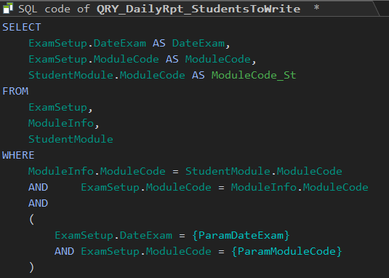

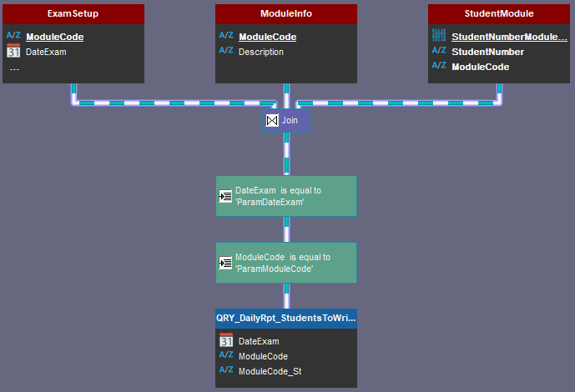

Screen dumps

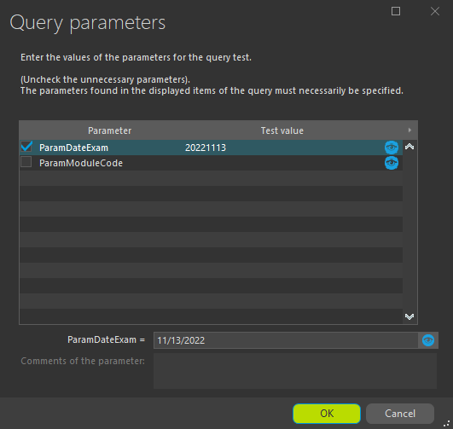

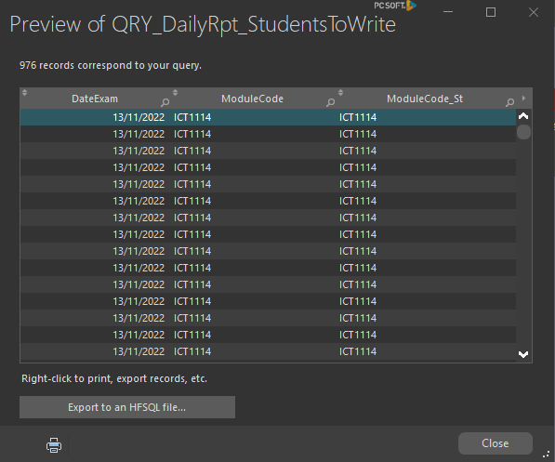

Modules expected to be written query

Reason

This query is used to get each record of modules that are expected to be written on a specific day. The date is passed as a parameter and all the records found for that date is returned.

Query

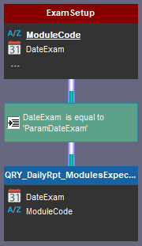

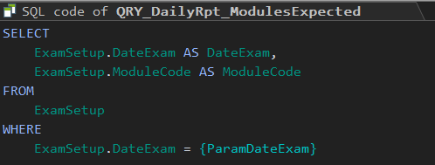

Screen dumps

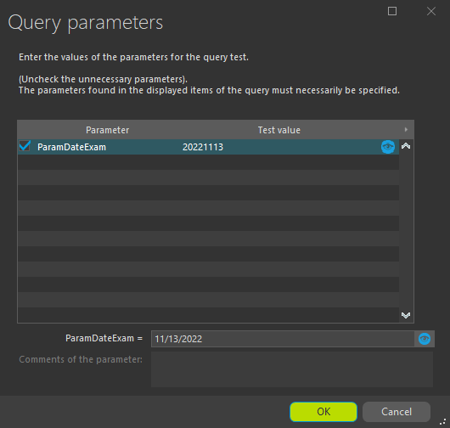

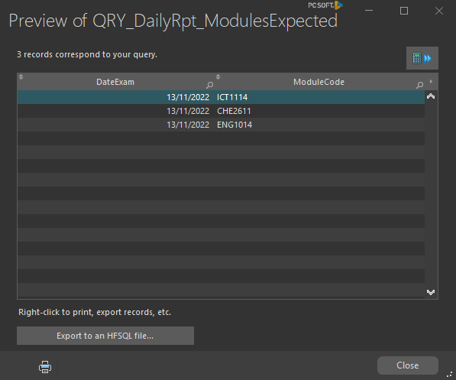

Populate chart query

Reason

A chart will be added that will view all the submissions for a specific date between 7:00 and 21:00. A function will be used to group the submissions by the hour. For example: Between 9:00 and 10:00 there were 352 submissions.

Query

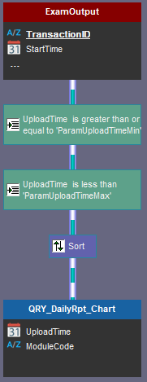

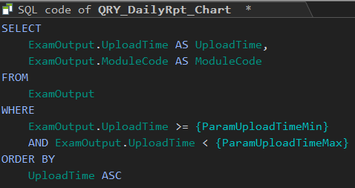

Screen dumps

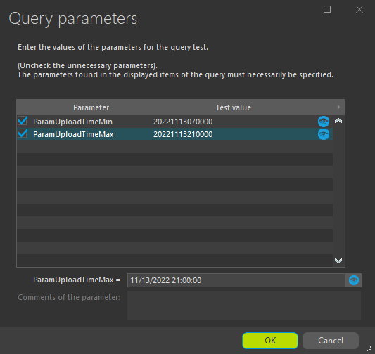

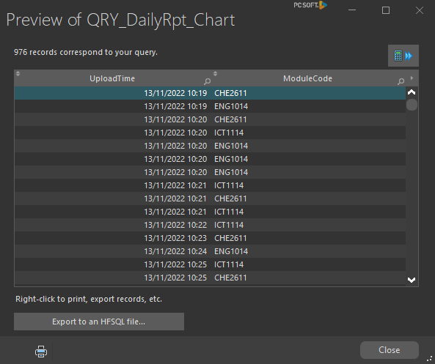

Staff module info query

Reason

A module code is passed as a parameter to this query, then the module leader for the module’s relevant information is returned. Basically, get the module leaders info for module code AST2652.

Query

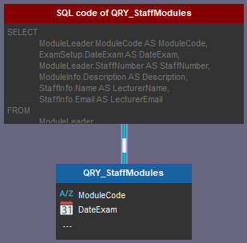

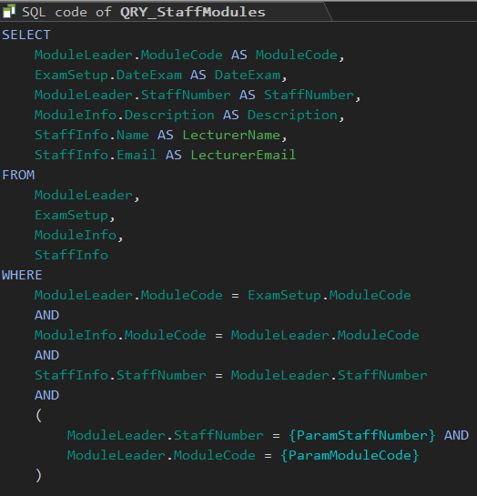

Screen dumps

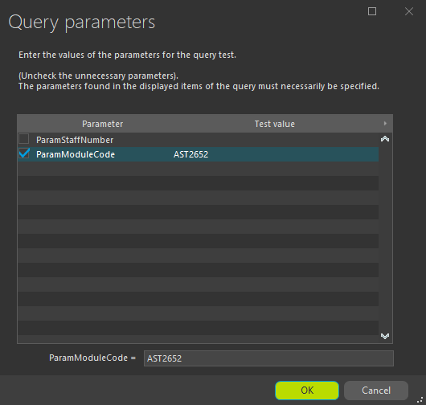

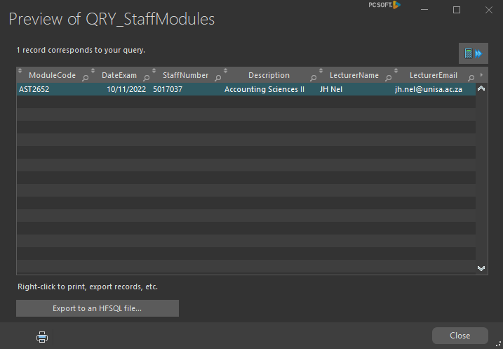

### Create the Weekly MIS report (5)

Total Unique uploads query

Reason

This query will be used to get the total number of unique uploads for the past 7 days. A minimum and maximum date is passed as parameters.

Query

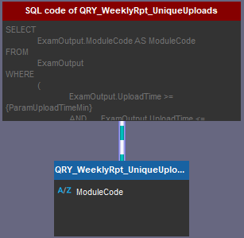

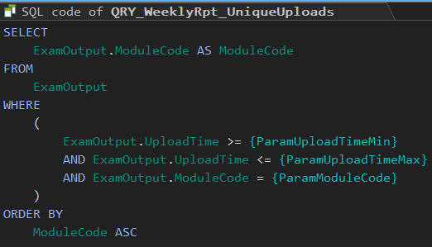

Screen dumps

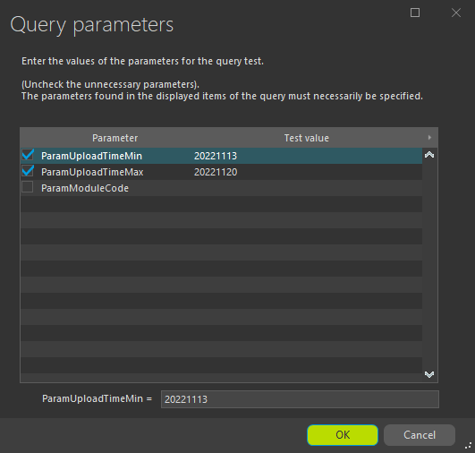

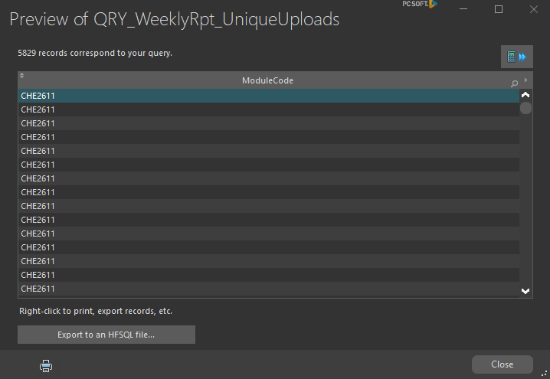

Modules completed query

Reason

This query will be used to get the total number of modules uploaded for the past 7 days. A minimum and maximum date is passed as parameters.

Query

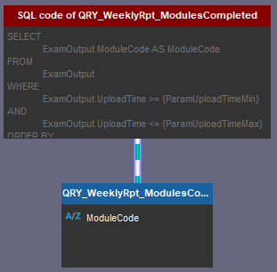

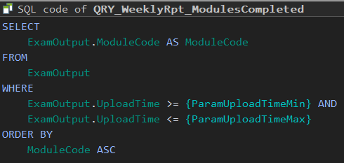

Screen dumps

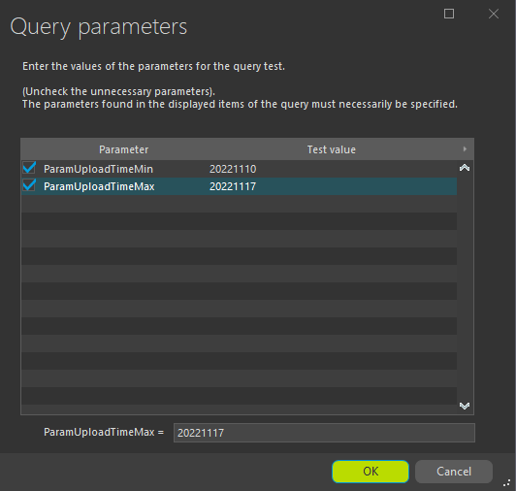

**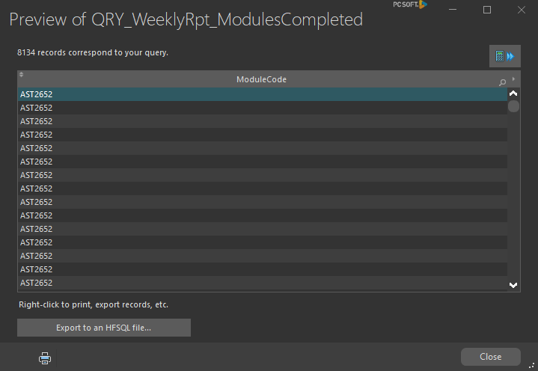**

Chart dates written for week query

Reason

A minimum and maximum date and time is passed to this query, the number of records for that week is returned. A function will be used to group the data by date to fill the chart.

Query

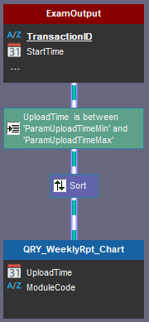

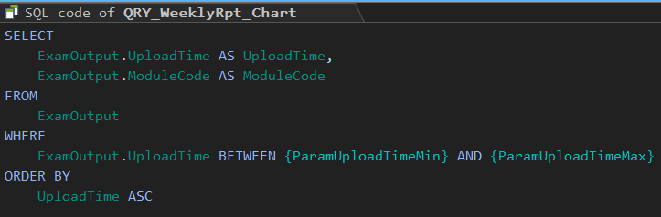

Screen dumps

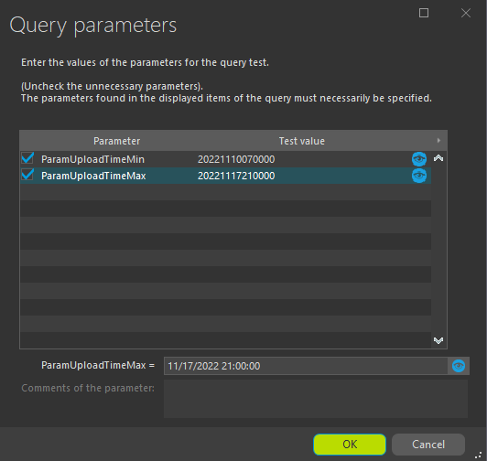

**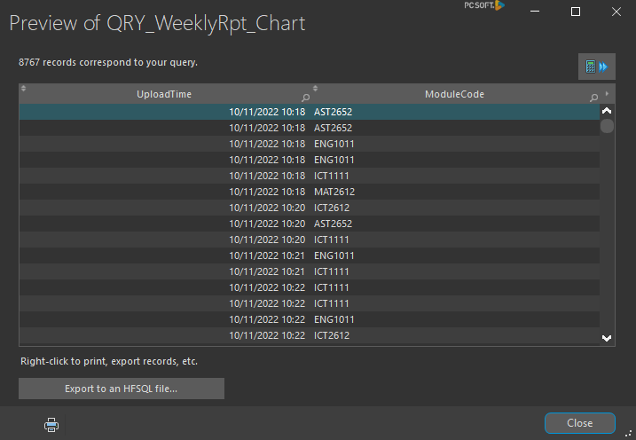**

Unique uploads by date query

Reason

A date is passed to this query as a parameter. The query returns all the uploads for that date. A function will be used to group the data by the hour to fill the chart.Example:total uploads between 9:00 and 10:00 on the 13th of November 2022 is 324.

Query

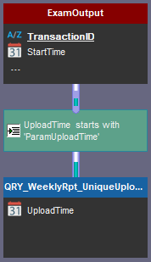

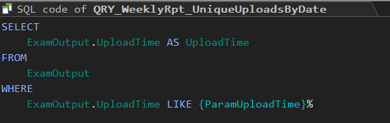

Screen dumps

**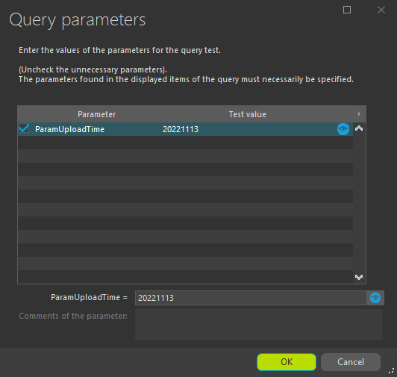**

**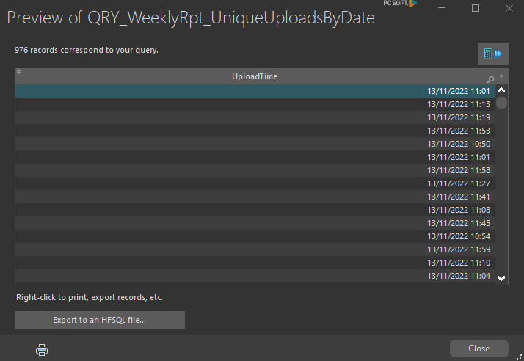**

Staff module info query (Re-Used)

Reason

A module code is passed as a parameter to this query, then the module leader for the module’s relevant information is returned. Basically, get the module leaders info for module code AST2652.

Query





Screen dumps





### Create one other MIS report (5)

Staff module info query (Re-Used)

Reason

A module code is passed as a parameter to this query, then the module leader for the module’s relevant information is returned. Basically, get the module leaders info for module code AST2652. This data will be used to fill a chart.

Query





Screen dumps





Module submissions module code query

Reason

After a module code is passed as parameter to this query, the query returns the records of all the submissions for that day. This data will be used to fill a chart.

Query

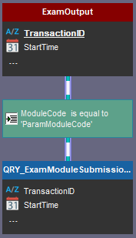

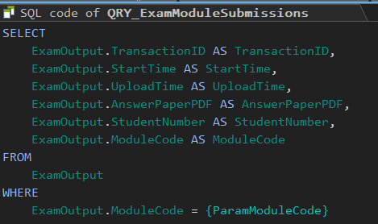

Screen dumps

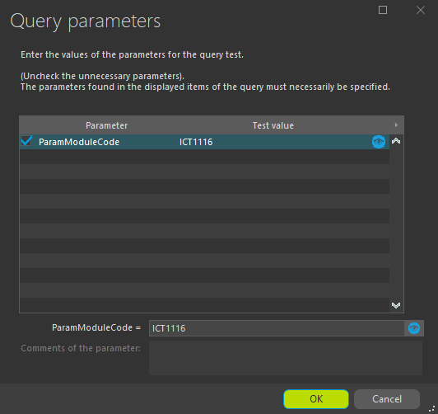

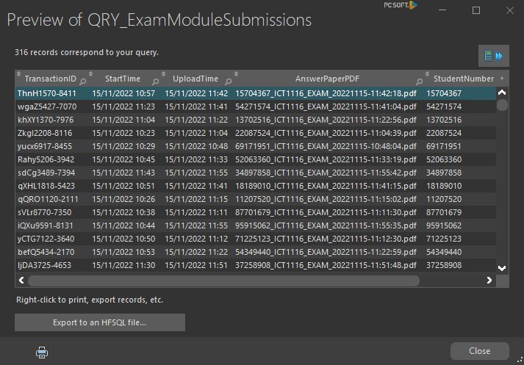

Lecturer summary chart modules query

Reason

This query accepts no parameters. It simply gets all the records uploaded and returns the module codes. A special function will be used to group the data to fill the chart.

Query

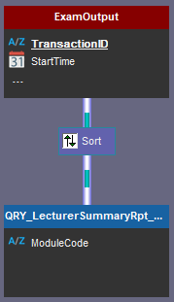

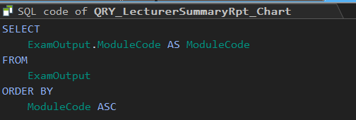

Screen dumps

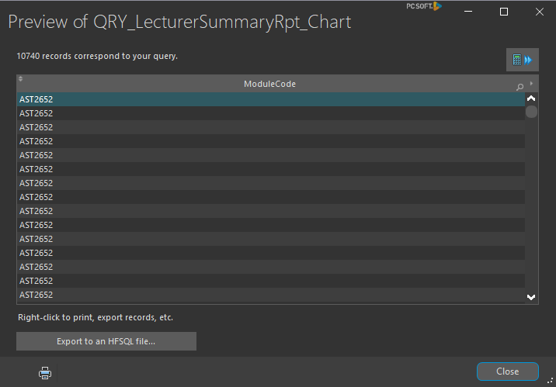

### Create one other MIS report (5)

Module Statistics query

Reason

This query accepts a module code as parameter and returns all the records for that module submitted. A function will be used to group the records by module code. Then more functions will be created to list each modules average, maximum and minimum upload times.

Query

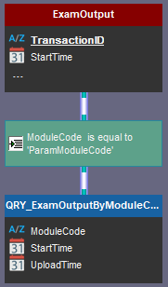

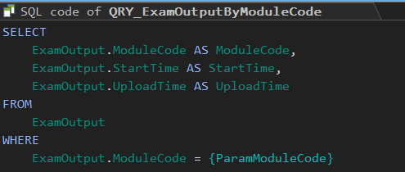

Screen dumps

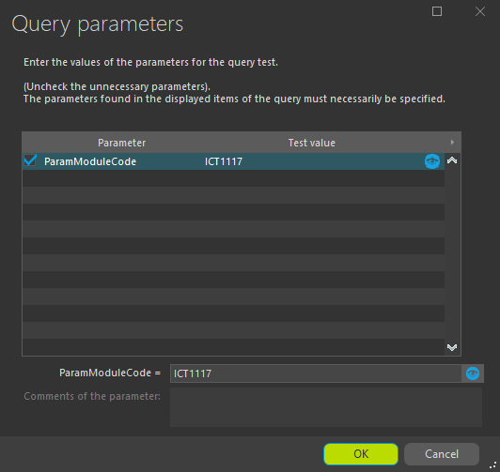

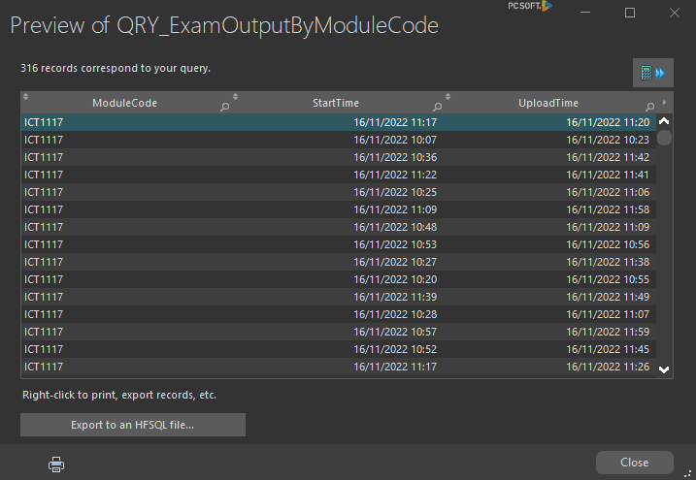

## 

## Section B = Graphical User Interfaces [20]

### Student login GUI (7)

**Creating the Graphical User Interfaces for the Student Login**

Screen dumps

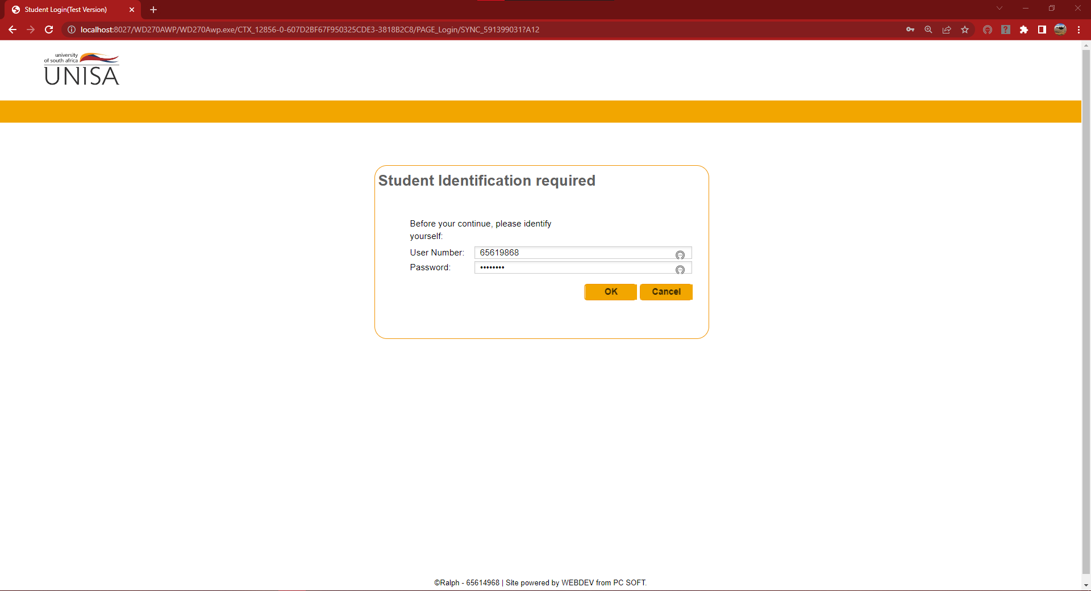

Code

**OK Button Click Code**

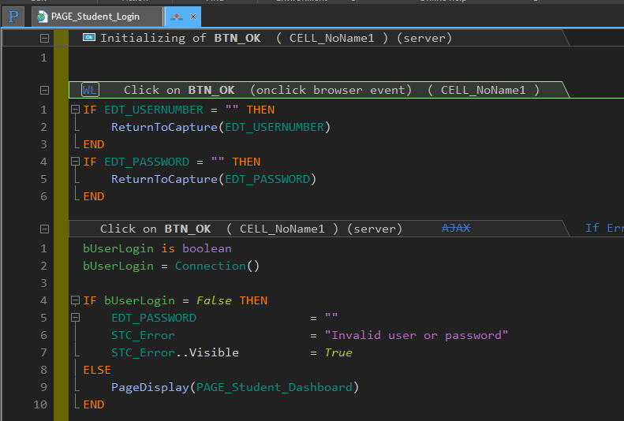

**Student Connection()**

**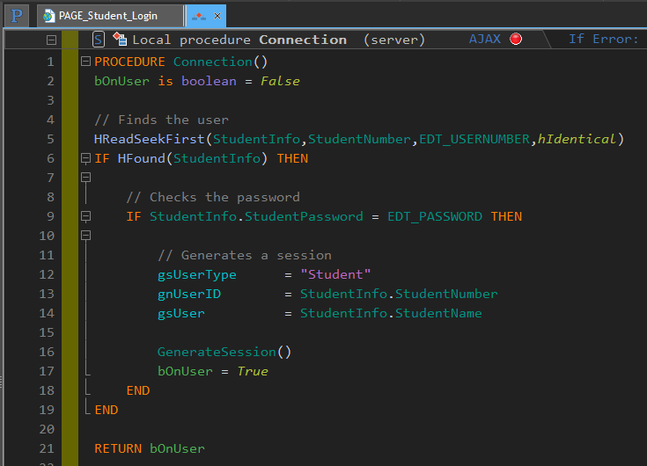**

**Student GenerateSession()**

**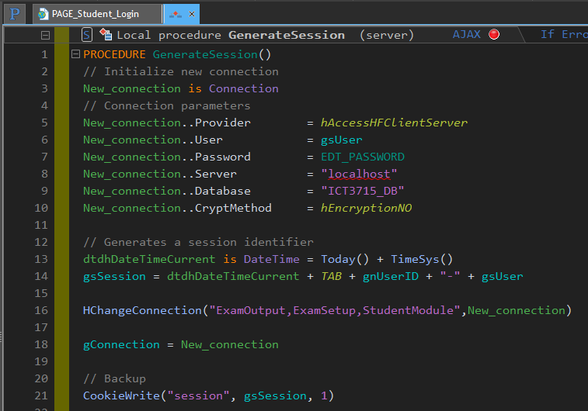**

### 

### Lecturer login GUI (7)

**Creating the Graphical User Interfaces for the Lecturer Login**

Screen dumps

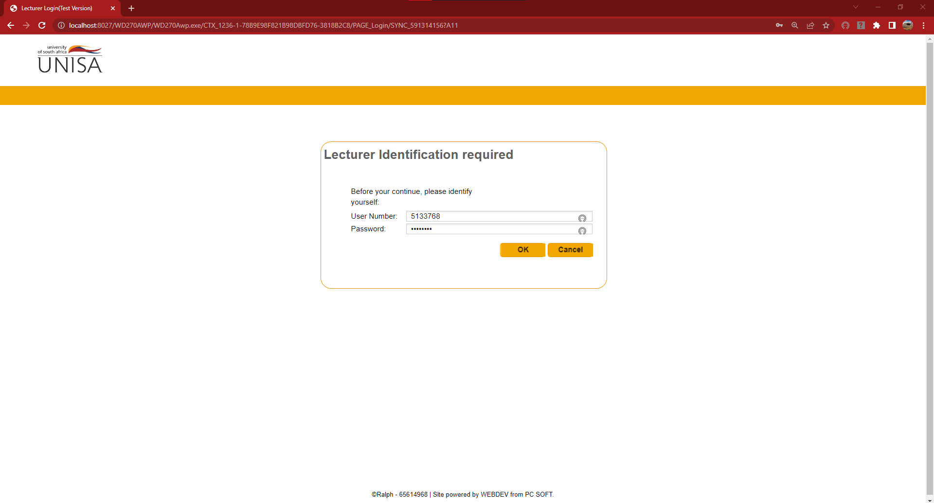

Code

**OK Button Click Code**

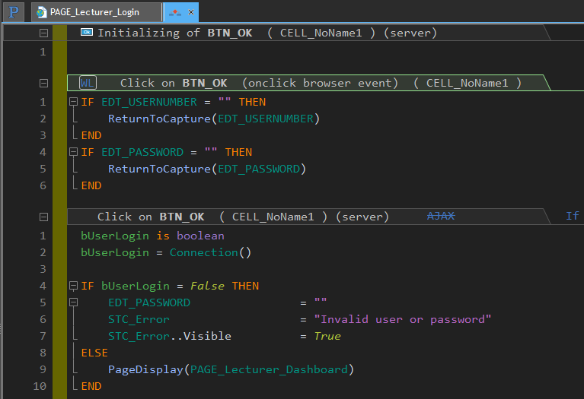

**Lecturer Connection()**

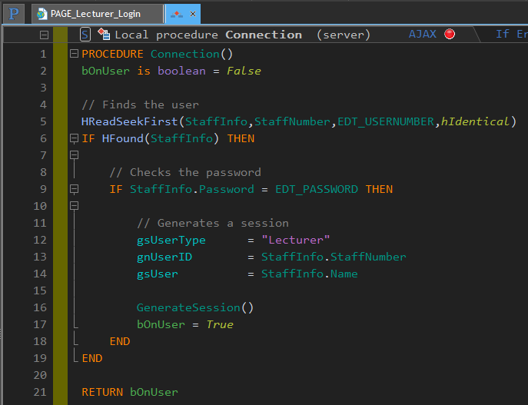

**Lecturer GenerateSession()**

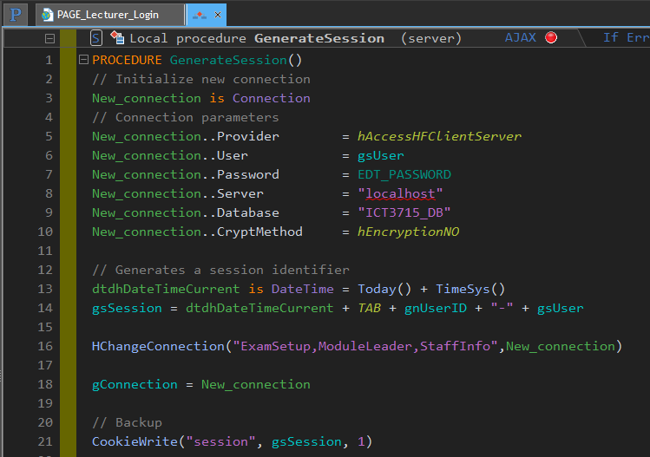

### 

### Exam Department (Staff member) login GUI (6)

**Creating the Graphical User Interfaces for the Exam Department (Staff member) Login**

Screen dumps

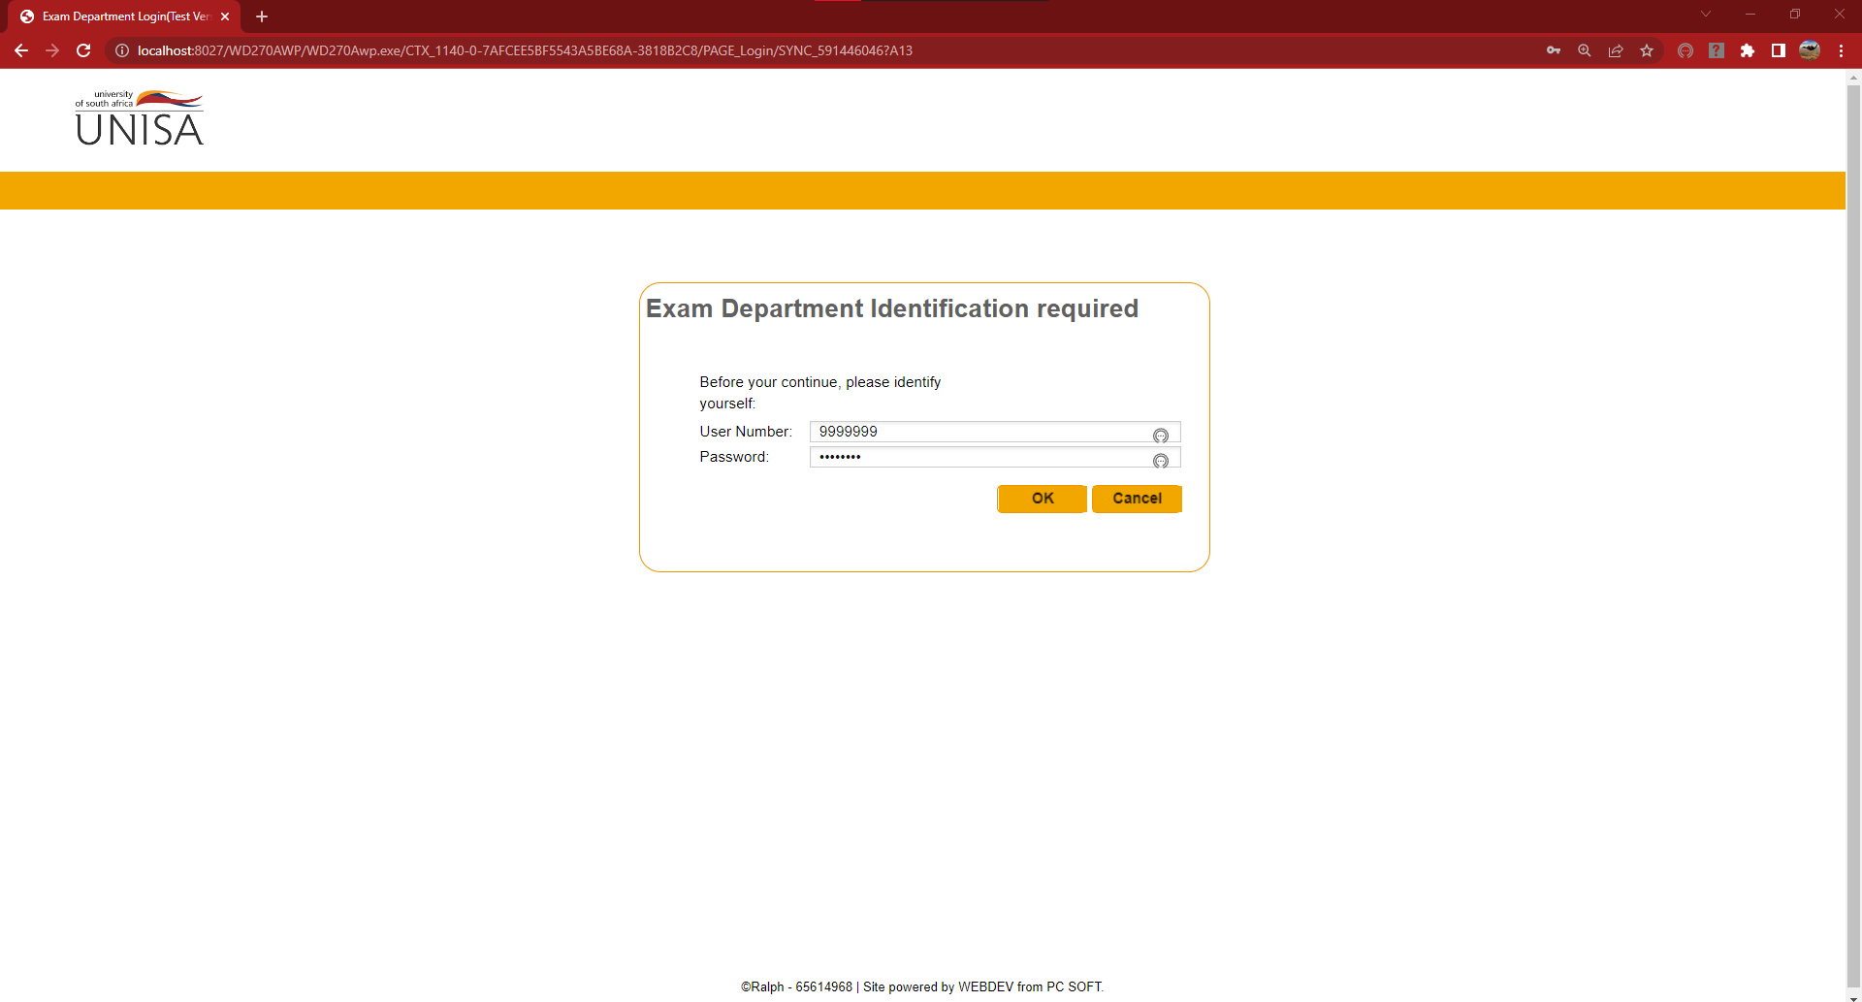

Code

**OK Button Click Code**

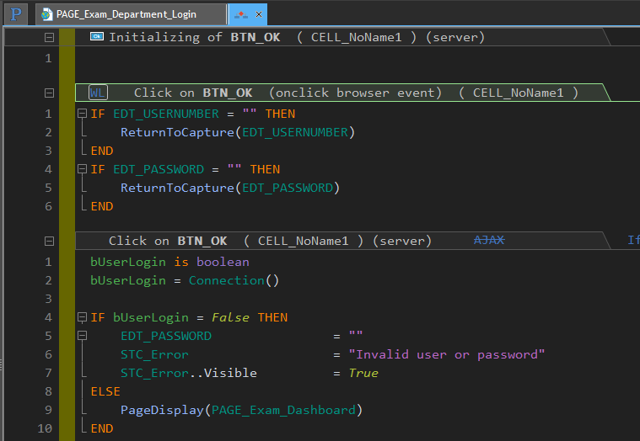

**Exam Department Connection()**

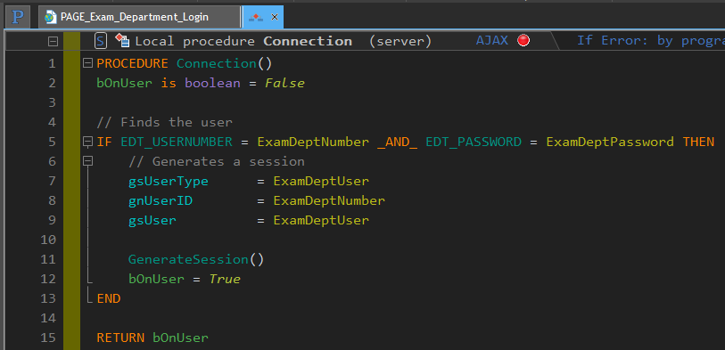

**Exam Department GenerateSession()**

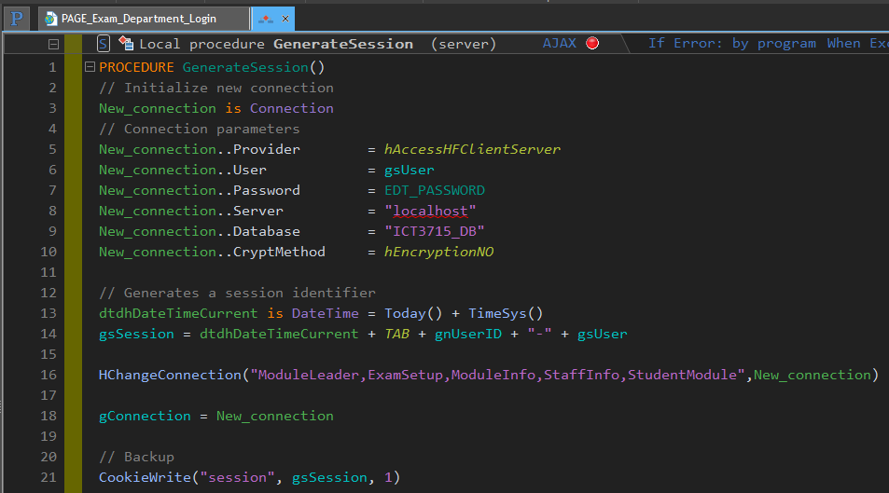

### User failed Login

**If any of the login screens has a failed login due to wrong username or password or nonexistence, an error is given. Example:**

**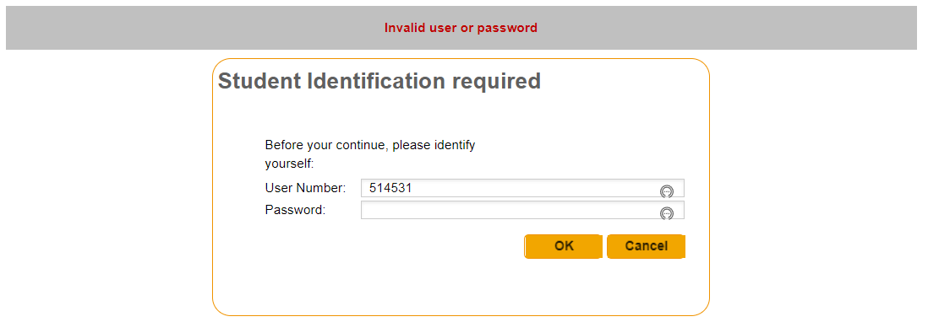**

# Assignment 2

## Section A = Database [20]

### Create the database for your system and importing the data from your .csv file (20)

The following explains how I created everything for the database and how I populated it using WEBDEV and WLanguage from my cleaned data file Data.csv.

**Creating the Database:**

1. The creation of the database can be done in multiple ways, I created the database structure when I created the project. During the project creation process, the wizard gives you the option to create a new database, use an existing one or no database to use. I selected the *“Yes, create a new database”* option.

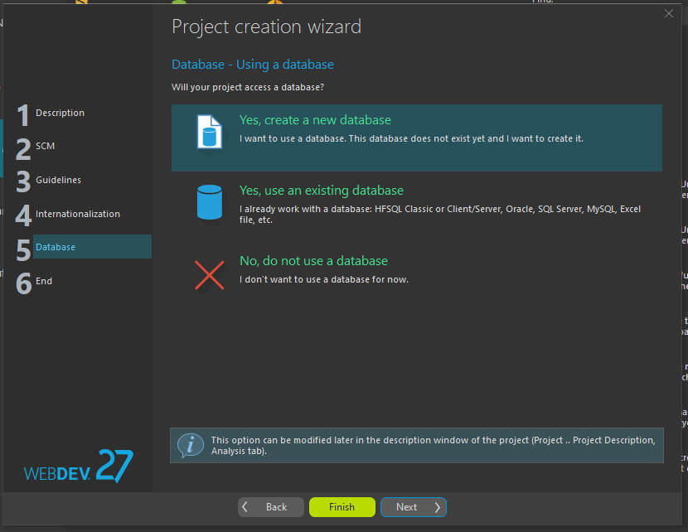

1. The following window is where you declare the name of the Analysis for the database, the directory to where it must be saved, and a description can be added (optional).

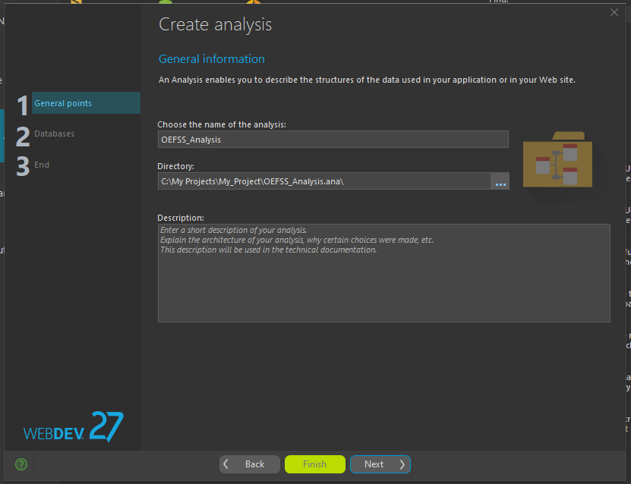

1. Then the type of database analysis is selected, in my case it is a HFSQL Client/Server.

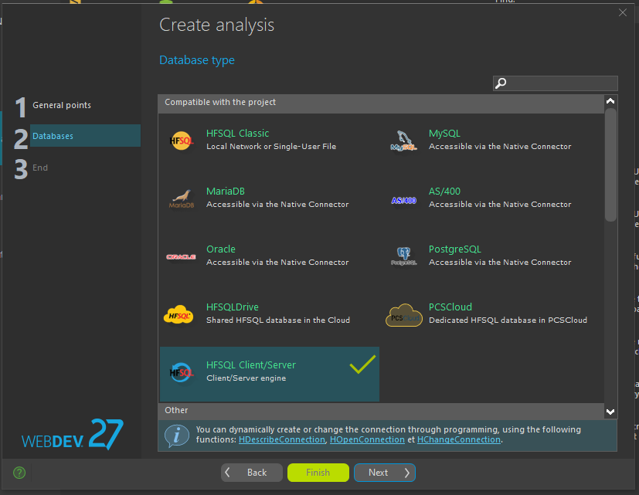

1. The next window is where the connection to the server is created along with its settings. The connection will be used or a new connection can be created in code to access the data in the database.

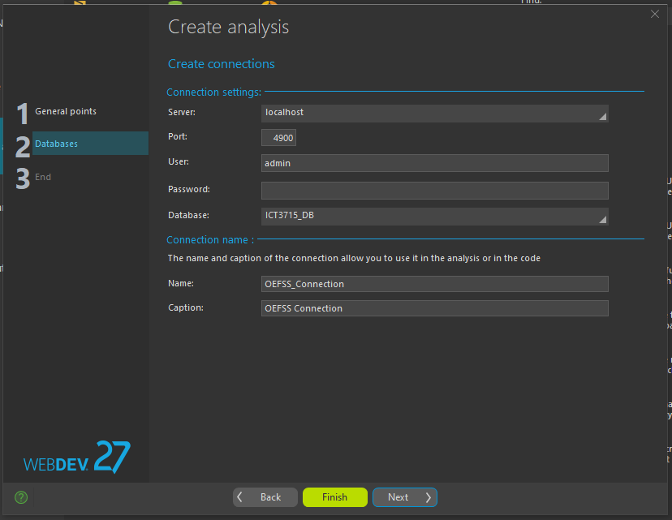

1. The last window is used to finalize the creation of the database. On Finish select, it is created.

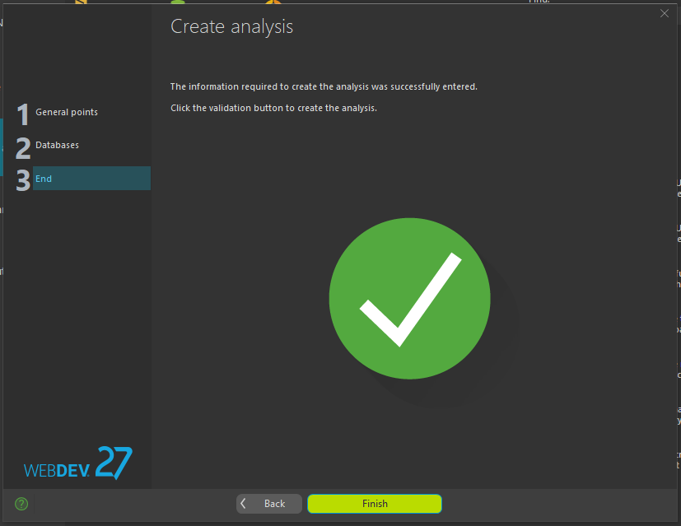

1. You are then directed to the Analysis page where the rest of the Database structure is designed.

**Create a Data File (Table):**

1. First select the New File icon in the Analysis tab to start the process.



1. The creation process is started. There are a few options to choose from, like using the data file format of an existing database and selecting from preset data files given by WEBDEV. I wanted to create a new data file so I selected the *”Create a new data file description”* option.

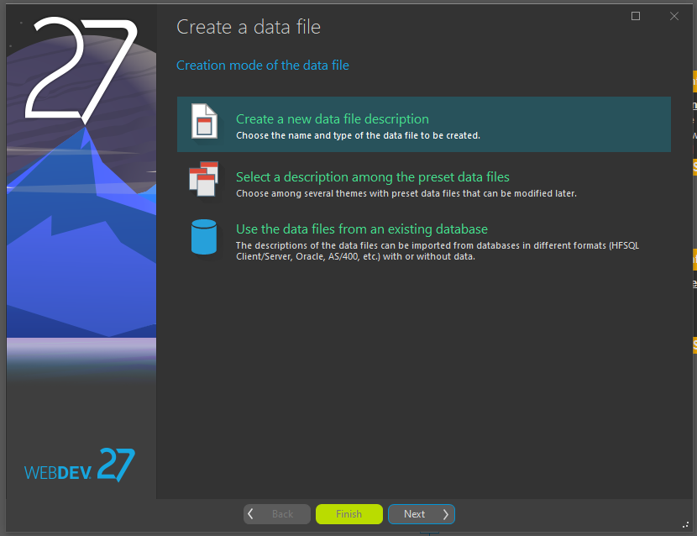

1. The next window allows me to select a name for my data file as well as how to handle the automatic identifier. As I will be creating my own Primary keys, no automatic identifiers are needed.

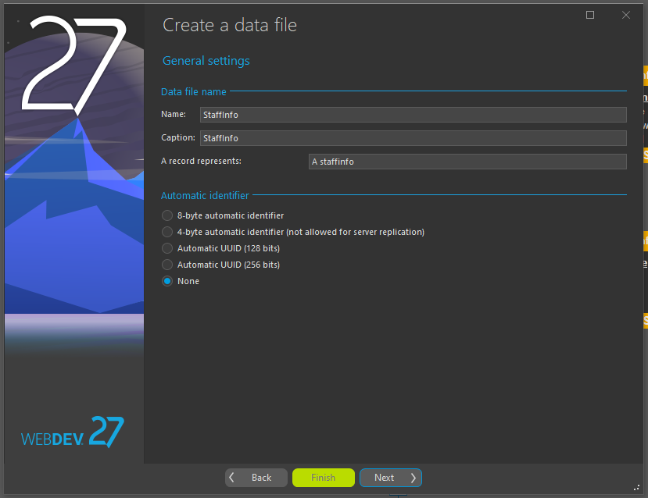

1. Here I get to select what type of data file I will be using. We will be using HFSQL Client/Server for this project.

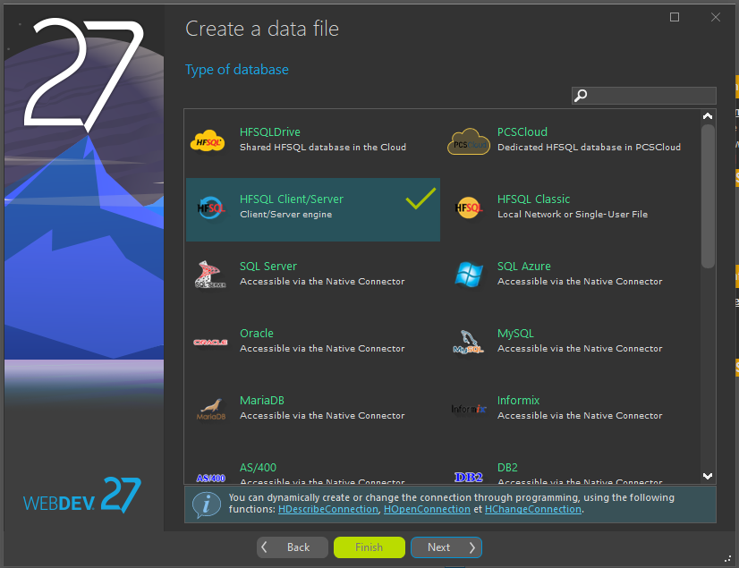

1. Because a Client/Server is used, a connection type is needed to allow access to the analysis. I already created a connection, so I selected my connection *“OEFSS\_Connection”*.

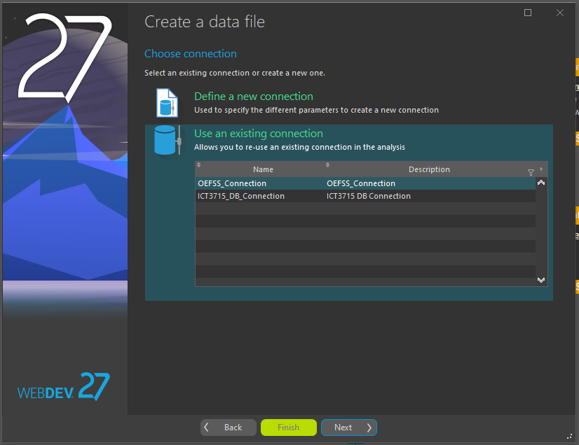

1. The last window validates the creation of the data file and on Finish select, it is created.

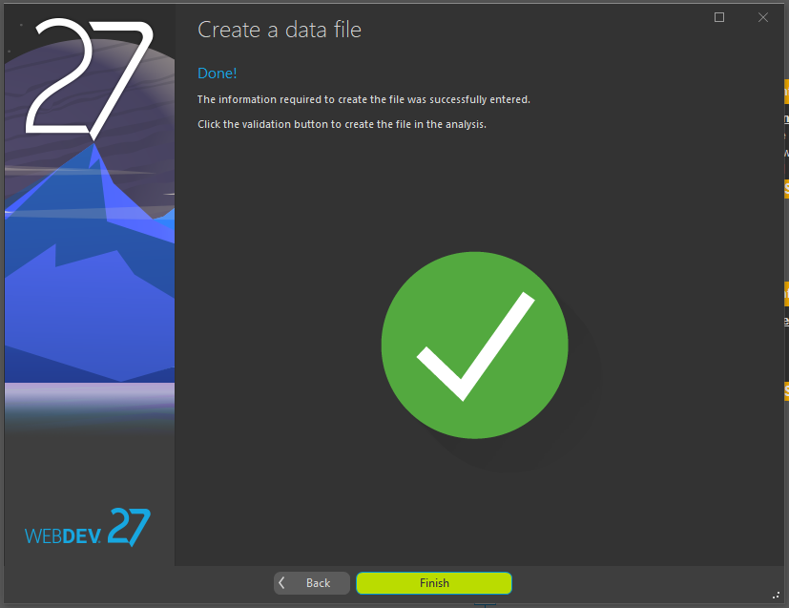

1. The item description window then opens and allows me to create each item (column) that will be present in the data file and allows me to describe each one’s attributes.

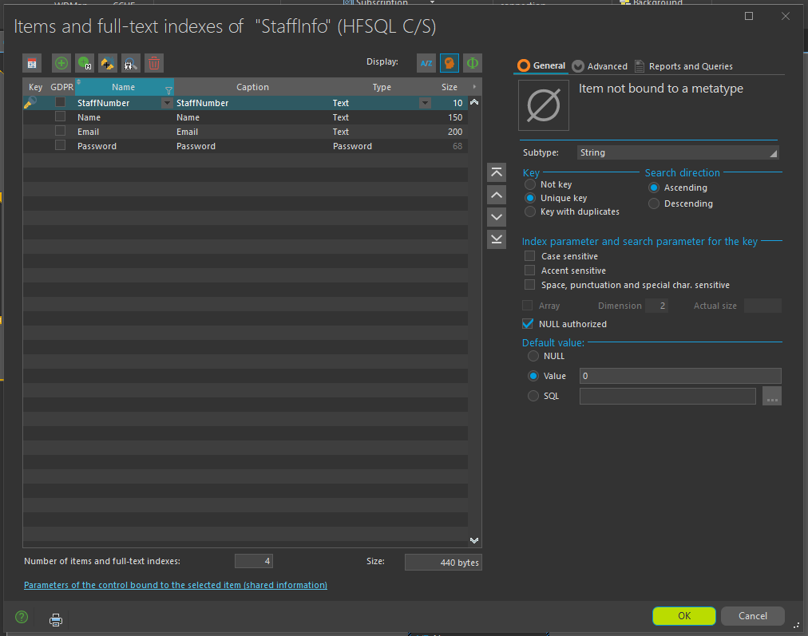

1. This process was followed for each data file created.

**Adding Links to Data Files**

1. First select the New Link icon in the Analysis tab to start the process.

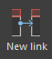

1. The first window allows you to describe the link type. Many to one, one to many, etc.

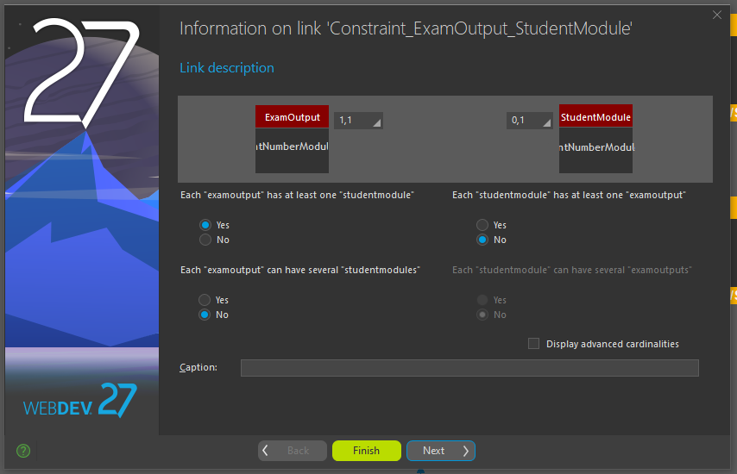

1. Here you must select a unique key to be used by the link of the first data file.

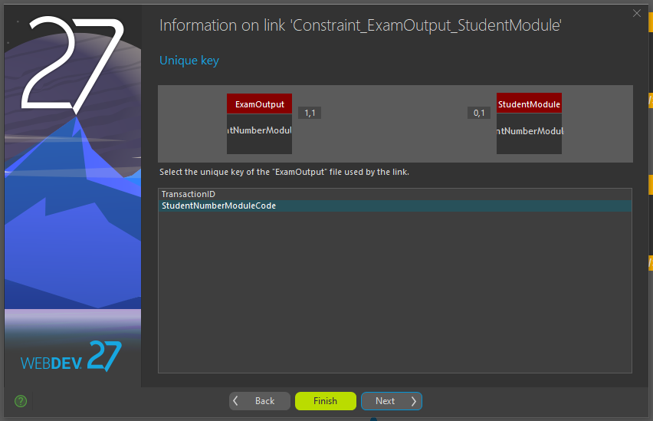

1. Then the link of the second data file must be selected or created in the data file if not available.

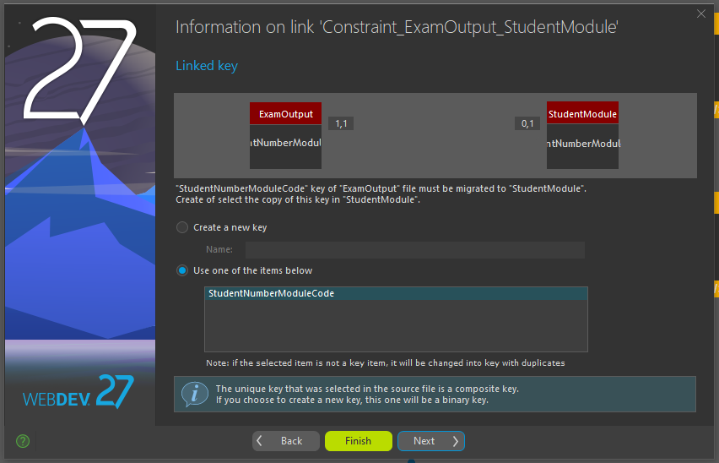

1. Here the integrity rules are set along with the link name.

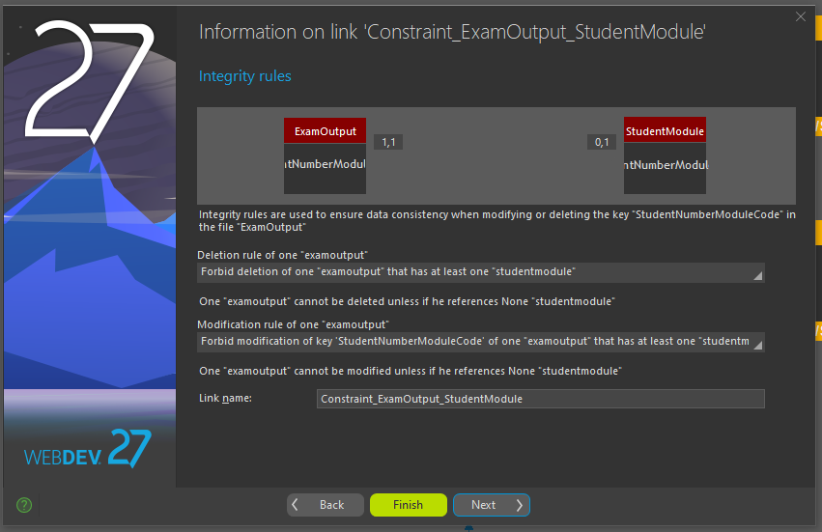

1. A final view of the link description is shown and on Finish select, the link is created.

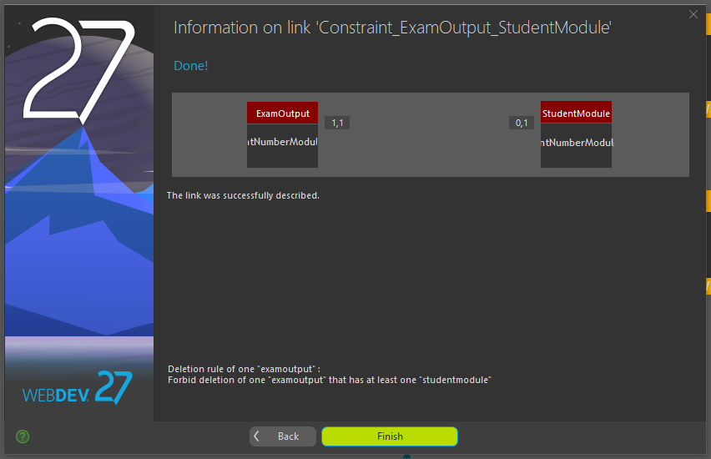

1. Here is the finished result.

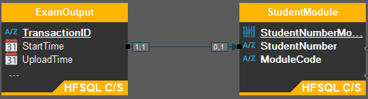

1. This process was followed to create all the remaining links

In the Analysis, the data files (Tables) were created, and items (columns) were created and described. The complete finished result is as follows:

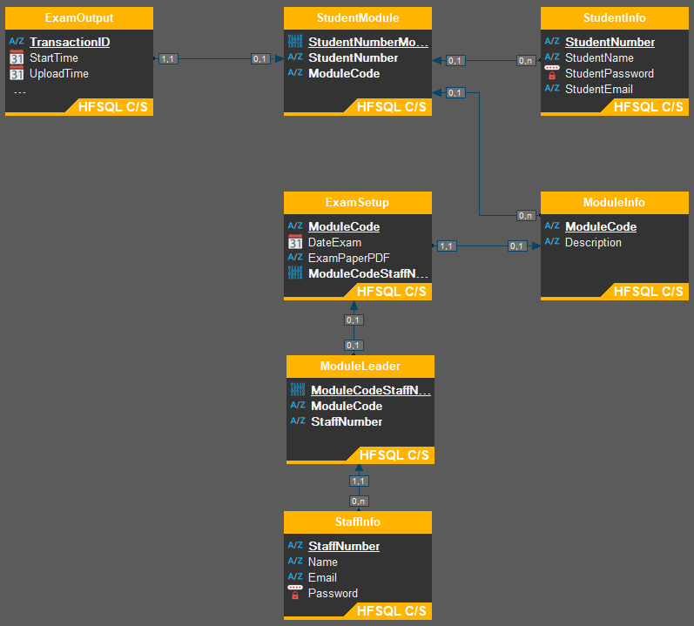

Data Analysis

Database Structure

**StaffInfo:**

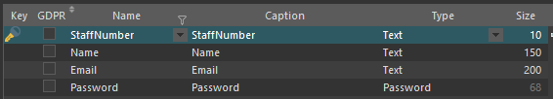

**ModuleLeader:**

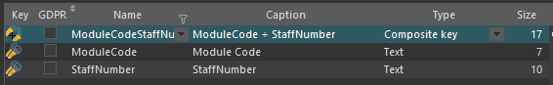

**ModuleInfo:**

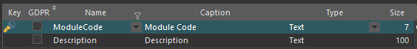

**ExamSetup:**

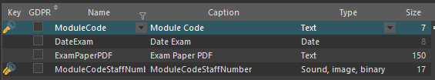

**StudentInfo:**

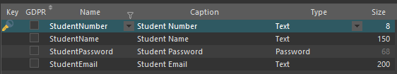

**StudentModule:**

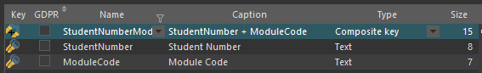

**ExamOutput:**

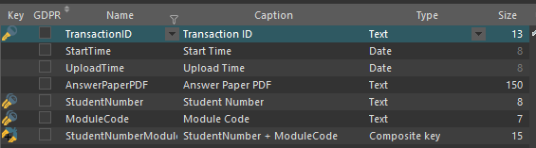

**Uploading Data:**

I created individual procedures for each Data file (Table) to run the uploading of the relevant data to the Database table.

In each procedure, the steps followed are relatively the same with minor differences as can be viewed in the code:

* Create the local variables and arrays that will be needed during the procedure execution.
* Open the file with the file path passed to the procedure.
* If the file has any lines, then continue.
  + Skip the first line in the file as it contains the column names.
  + Make sure it is not the end of the file then assign the first line to a string.
  + While its not the end of the file:
    - Split the string line read into an array of strings
    - Assign the Primary key to its variable and check if it already exists in the table, if it does, go to next line, else continue.
    - Assign the rest of the string values to their variables and do any formatting needed. For example, change a string date value to a date form.
    - Assign the final values to a new data file by adding each field, Datafile.item = value
    - Then add the item to the table.
    - Read the next line.
  + If it is the end of the data file, then close the file read.

**Procedure UploadStaffInfo:**

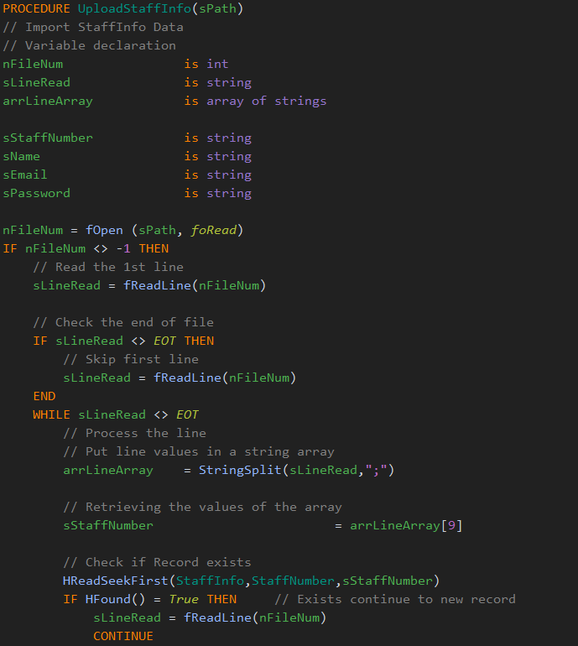



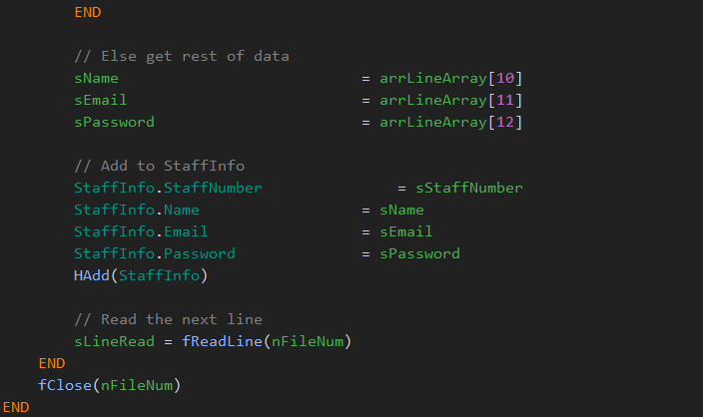

**Procedure UploadModuleLeader:**

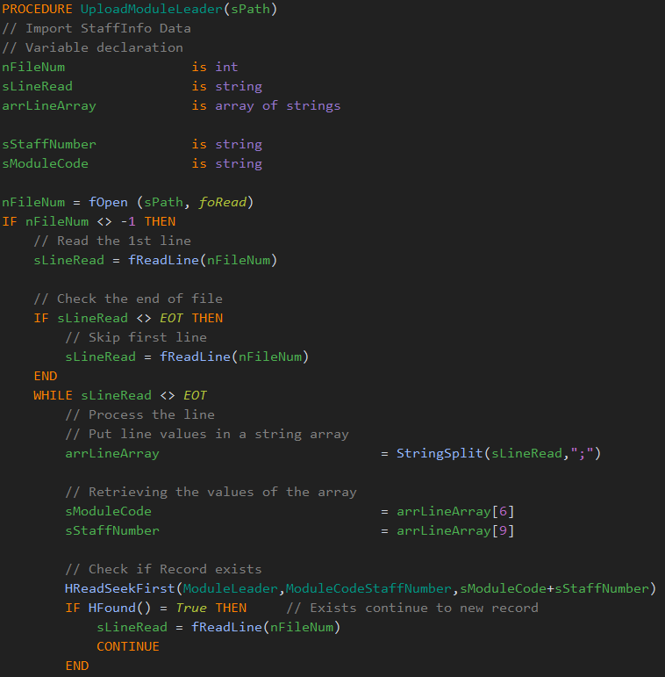

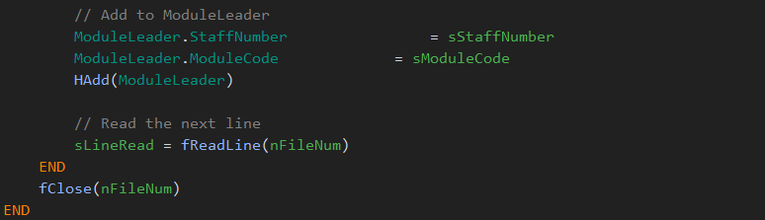

**Procedure UploadModuleInfo:**

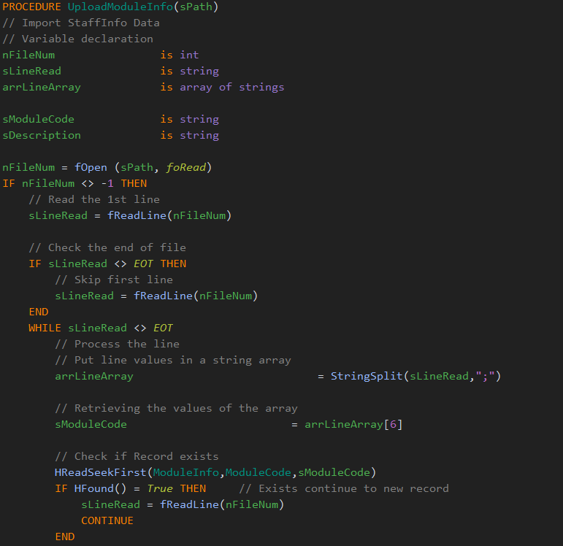

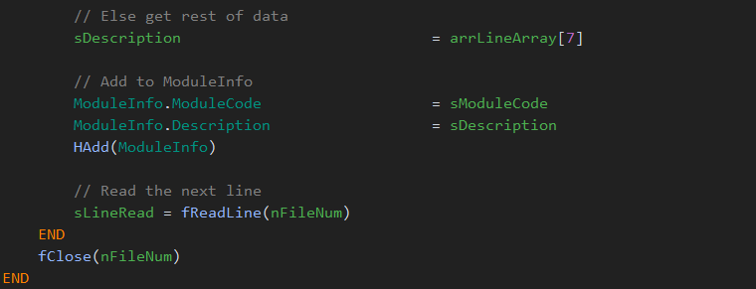

**Procedure UploadExamSetup:**

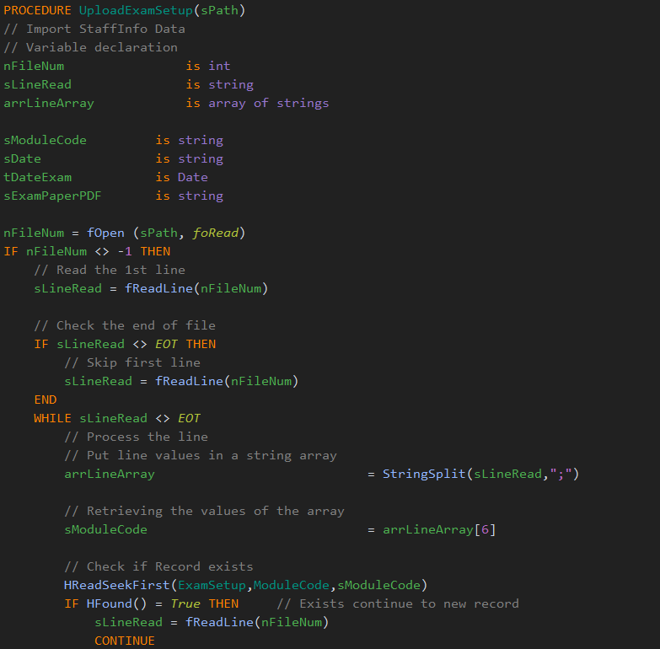

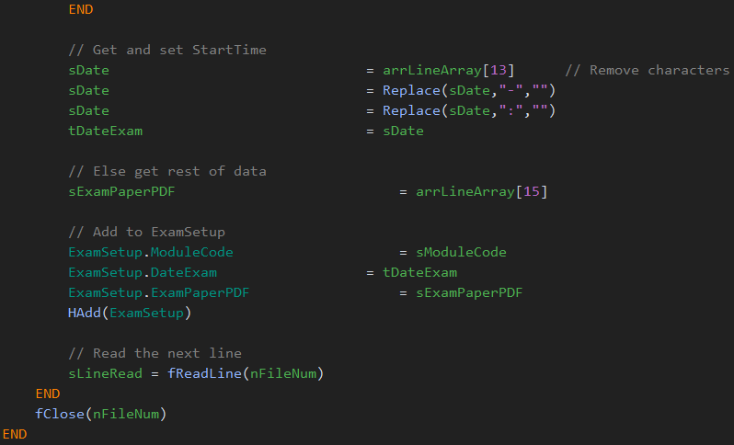



**Procedure UploadStudentInfo:**

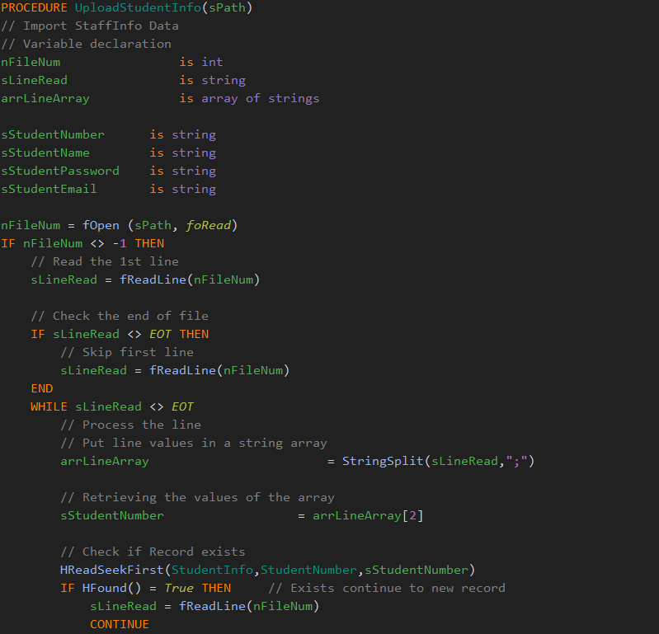

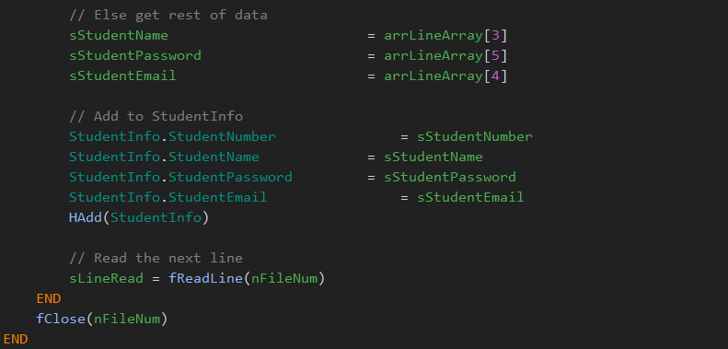

**Procedure UploadStudentModule:**

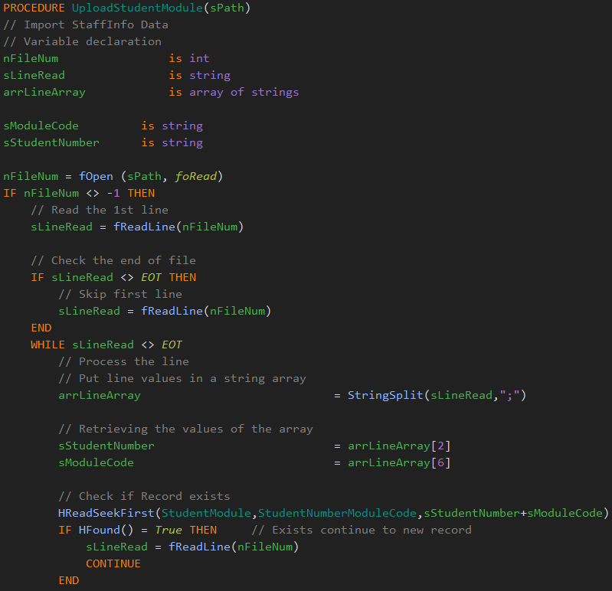

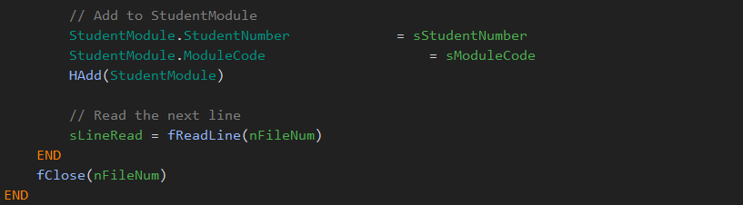

**Procedure UploadExamOutput:**

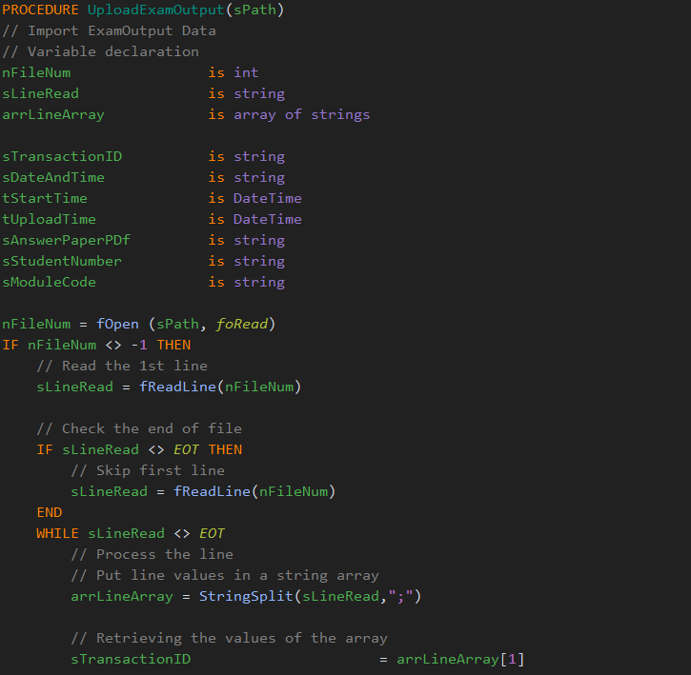



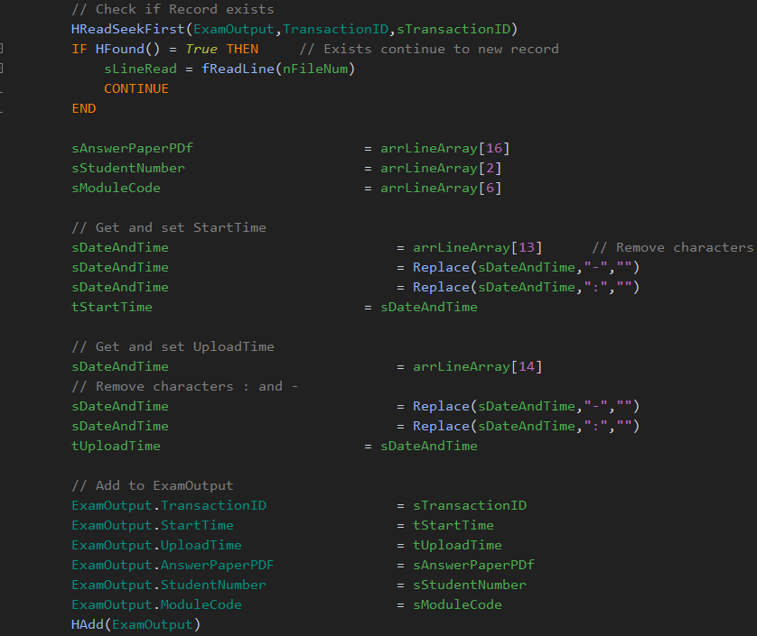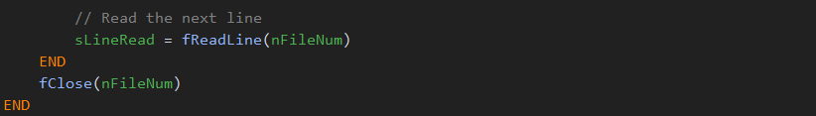

**Implementation of Procedures:**

To implement these procedures and upload all the data, I started with my site creation.

I started with a simple Home page with some of the project details to start off with. A Login button is visible that redirects the user to the login page.

**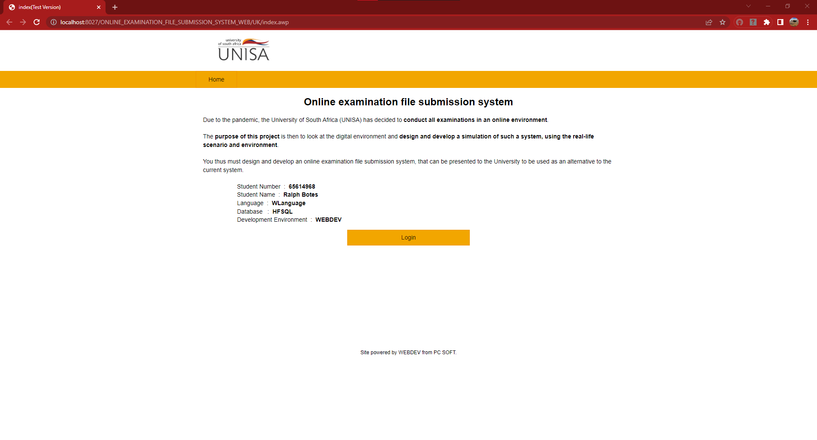**

The Login page consists of a simple user number and password input fields. Added are details for different login users but at this stage we are going to concentrate on the UNISA Admin Login details. After the details are entered and validated, an admin session is created, and the user is directed to the Admin Dashboard page. (More on the login procedure later.)

**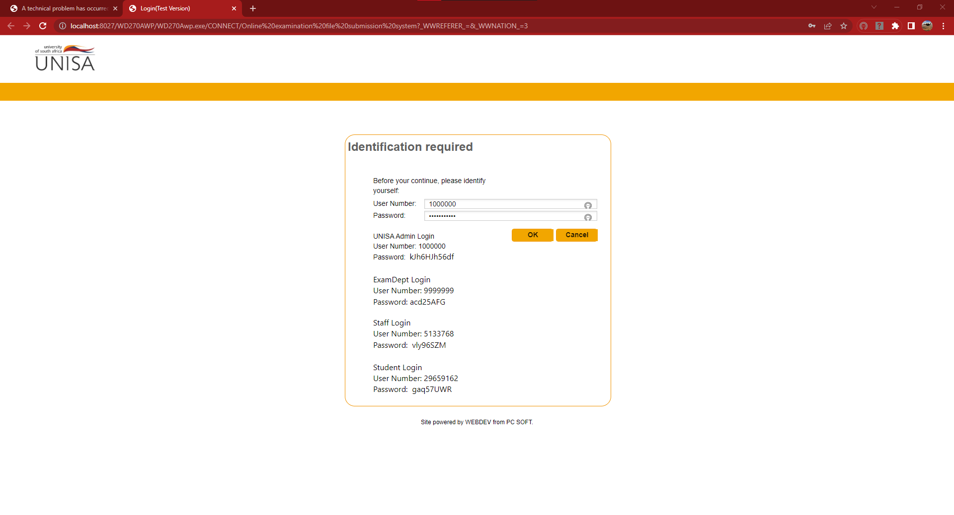**

Once the Admin user is logged in, a file path edit field and 7 buttons are visible. The edit field is used to input the cleaned data in the csv file’s location on the admins drive. After this field is added and valid, the user can start uploading the data, one table at a time, by simply selecting the buttons for the relevant table.

**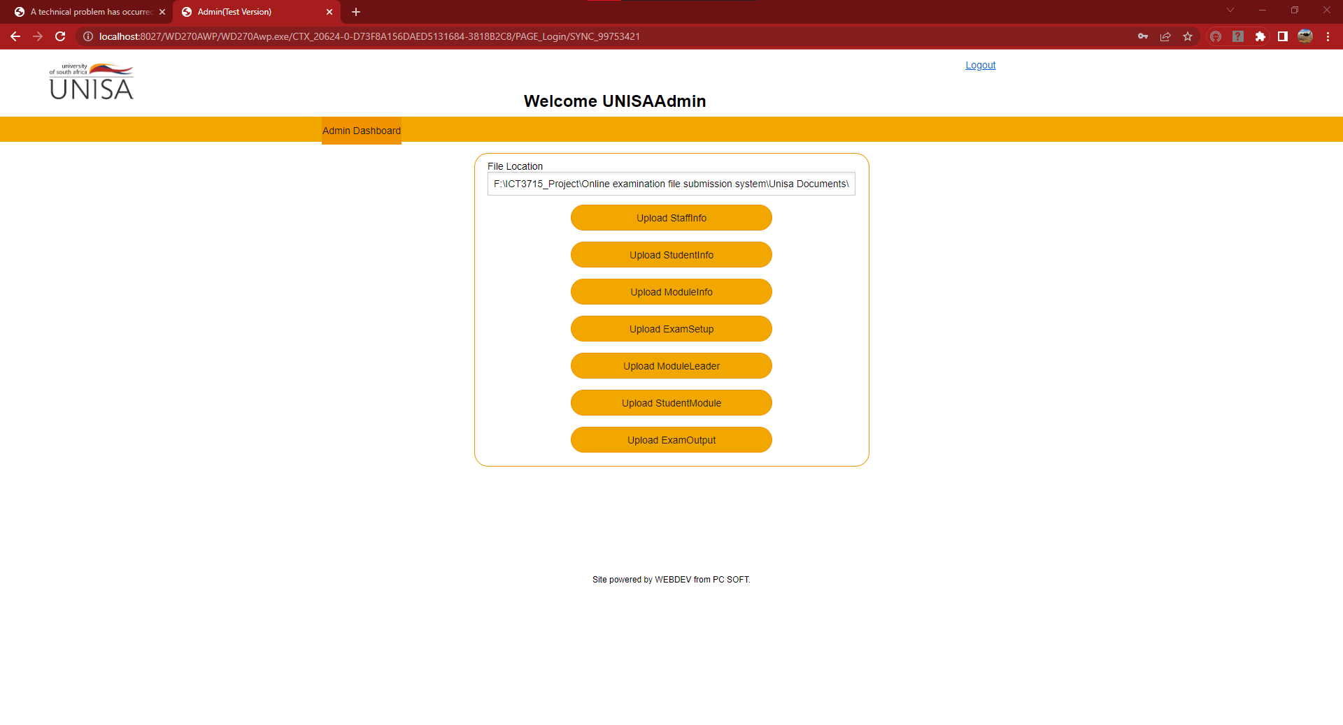**

On each button select, a popup message appears that informs the Admin user that the process may take some time. When the user selects the Ok button, the process starts and once it ends, the popup closes, allowing the Admin user to select the next data import button or logout.

**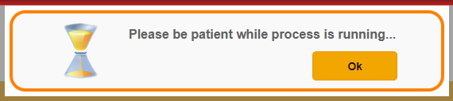**

**The Data:**

To view the data after it has been successfully uploaded to the database:

1. In WEBDEV, I select the HFSQL icon in the Tools tab.

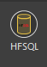

1. This opens the HFSQL Control Center where I can connect to my HFSQL server and view the database. After I input the relevant data and press Ok, I enter the Command Center.

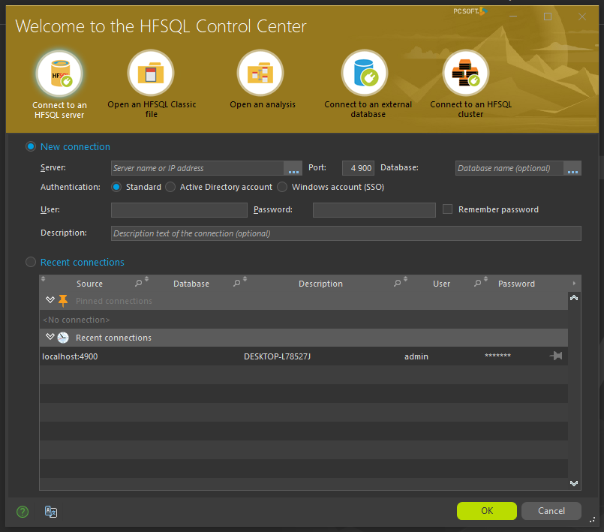

1. The window displays my database name and the filled tables below in a tree view form.

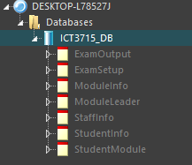

1. 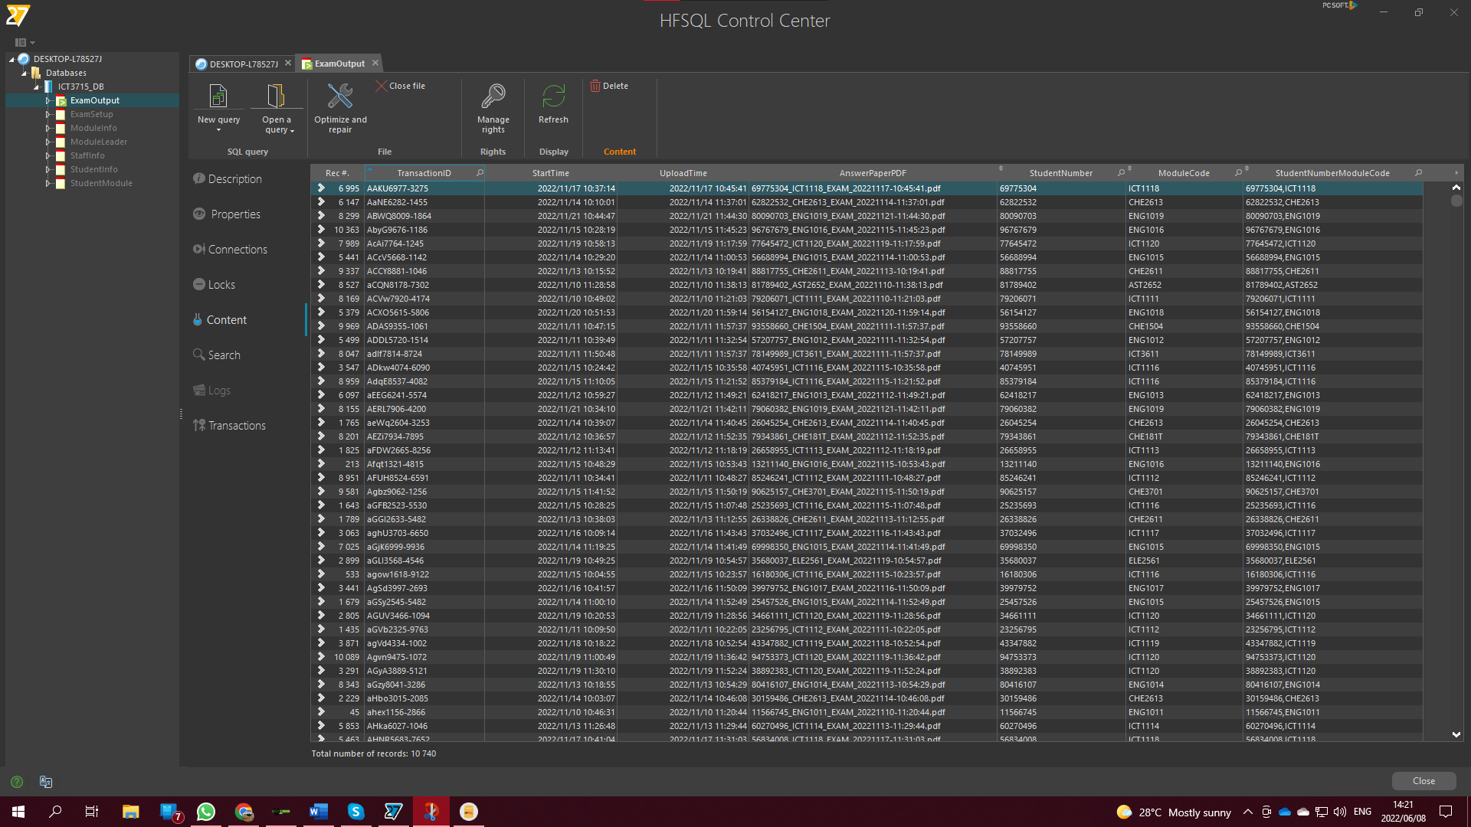Below can be seen how the data has been filled into the ExamOutput table.
2. 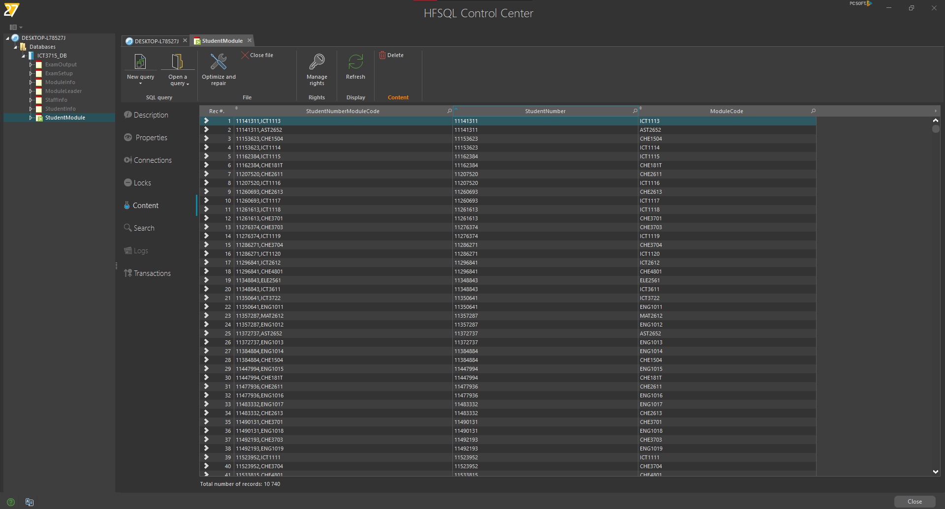Following are the rest of the filled tables.

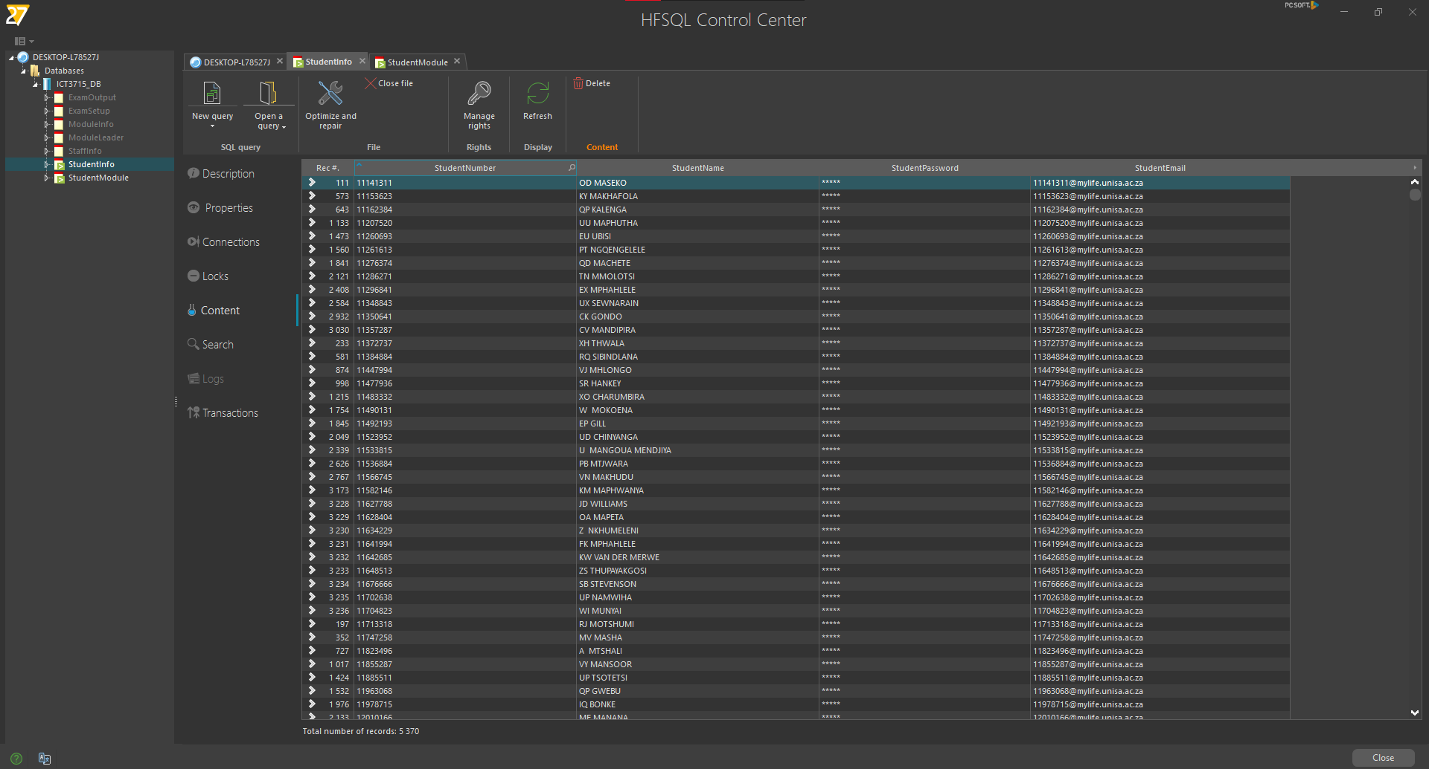

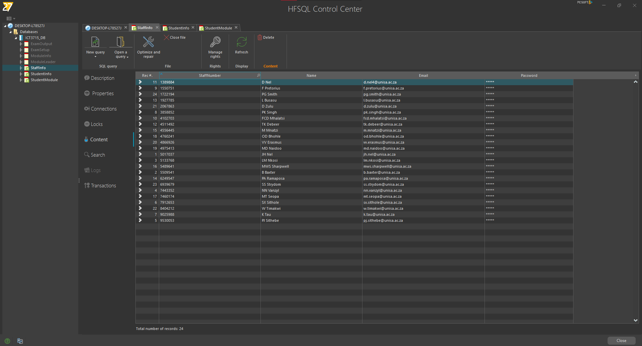

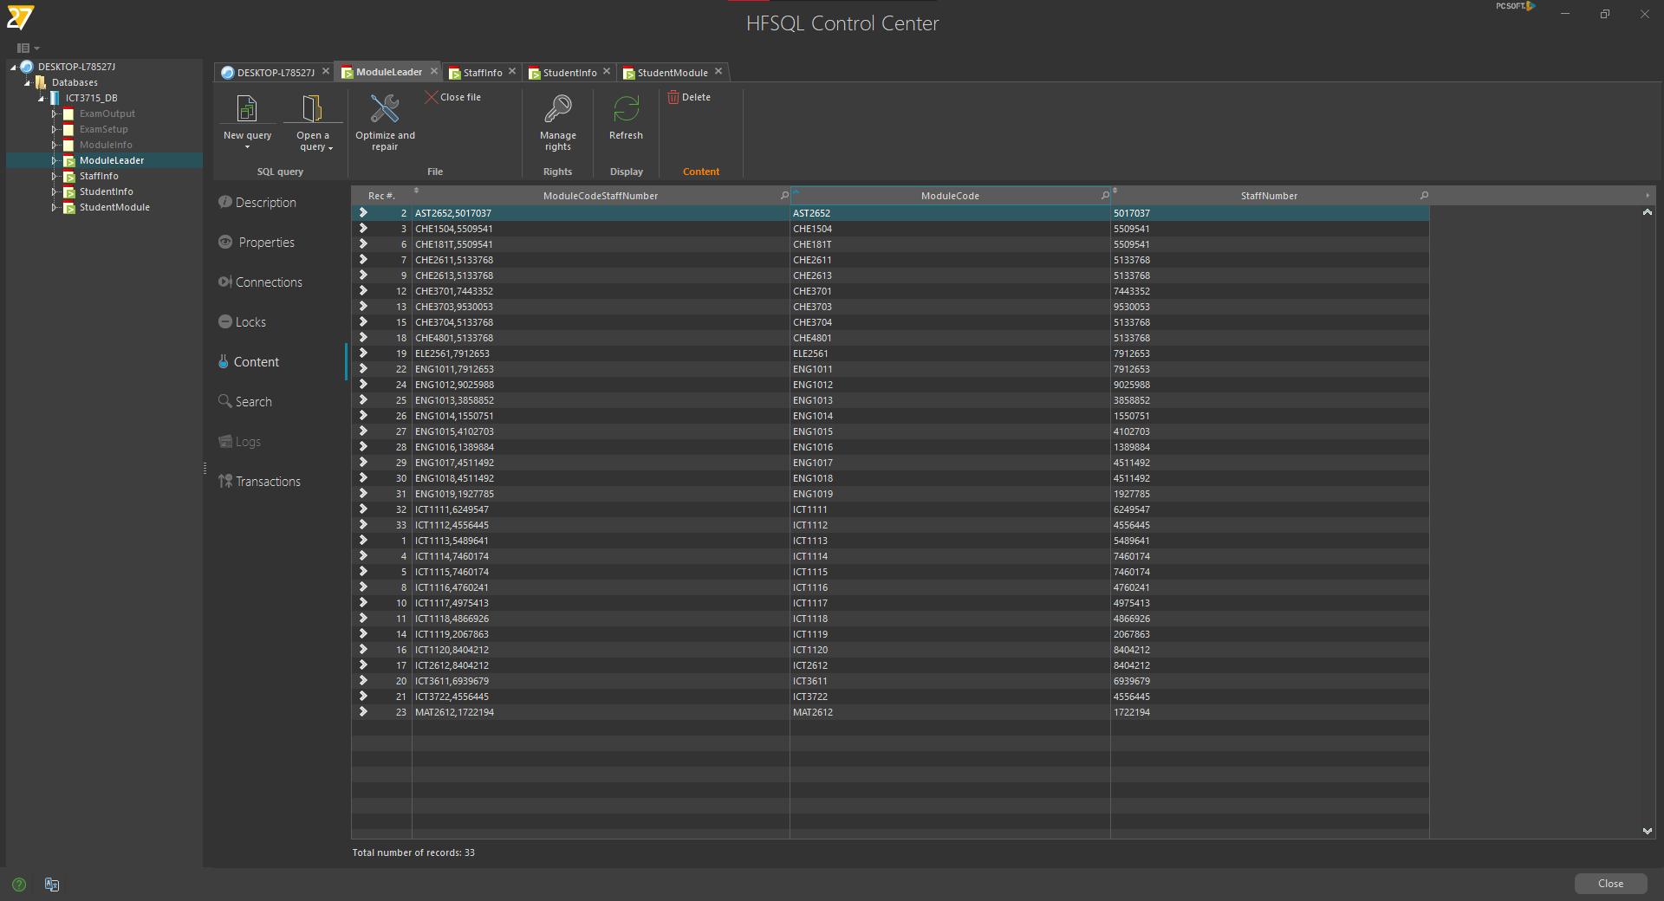

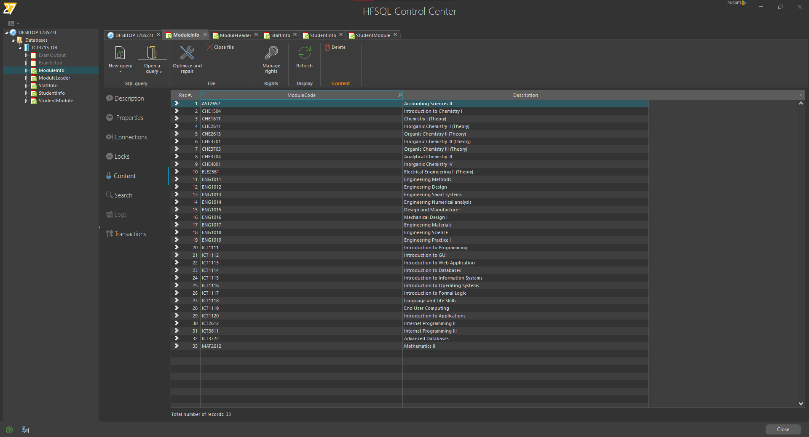

**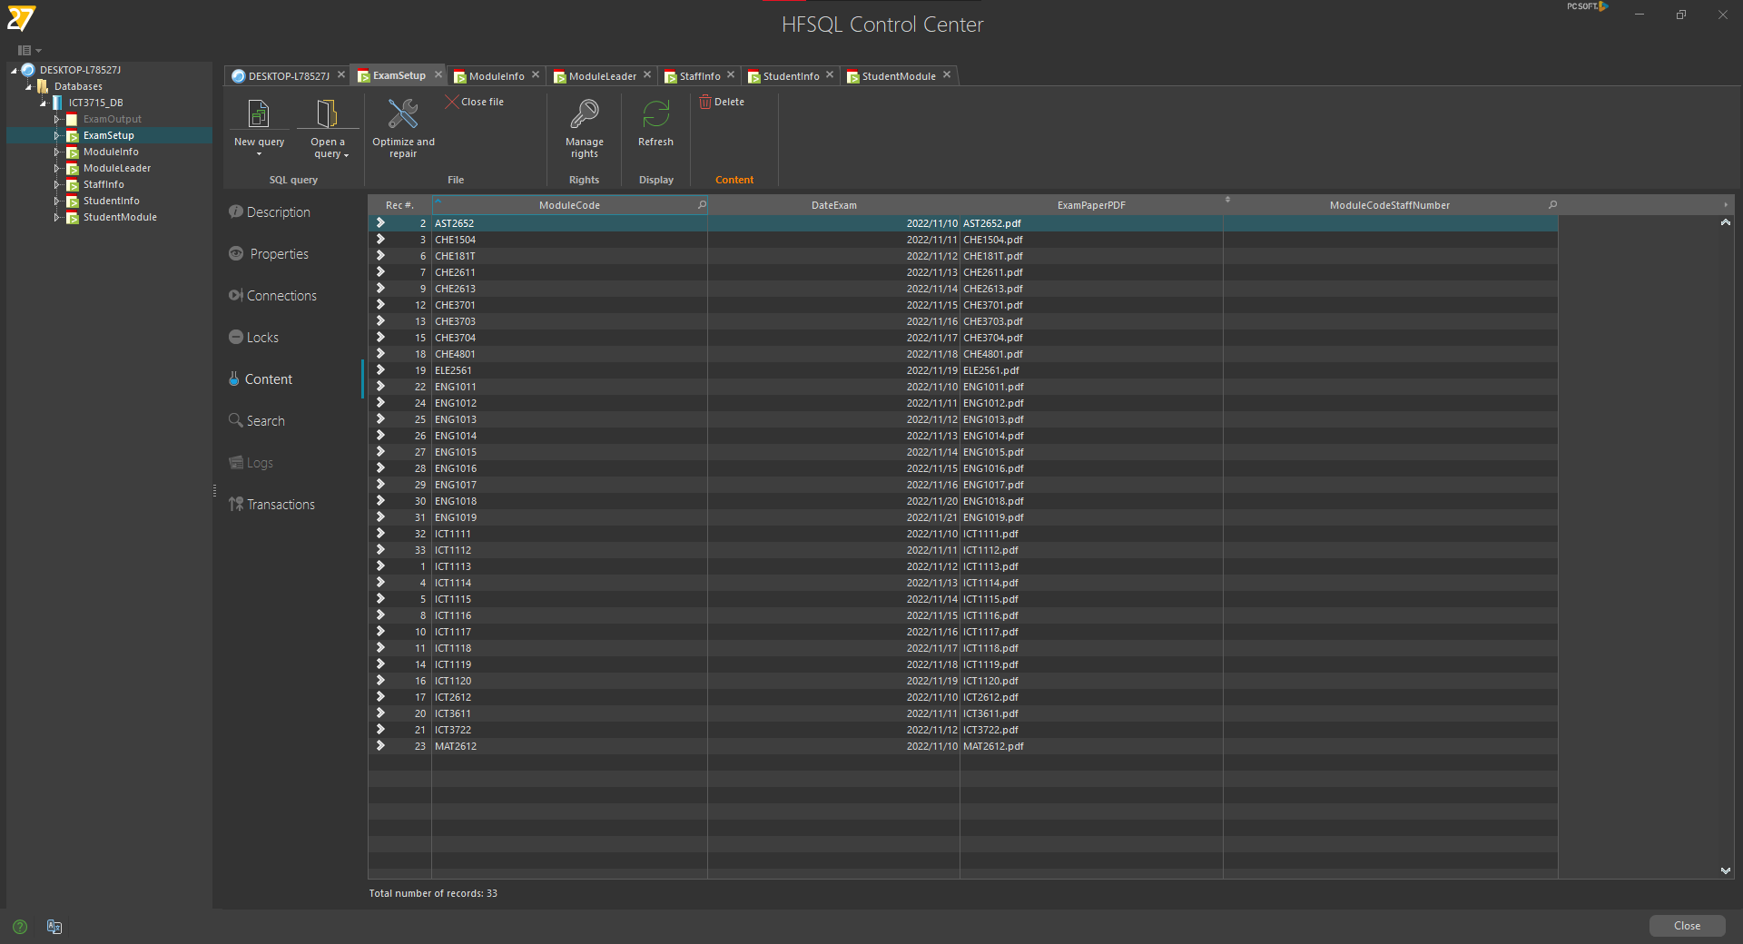**

**Problems I had**

1. When designing my procedures, I had some trouble getting to the right format for my dates and times to upload to my database. I used the WEBDEV’s Debugger to keep track of how the data changed at every line. I created a few test variables and made single changes to each. WEBDEV’s Debugger allows for live debugging that allowed me to view each line before and after it executed to determine what happened. I then used the tests I made and got the exact date and time formats I needed to upload the data to my database.
2. I struggled with the ERD / Data Analysis diagram as WEBDEV allows for foreign keys, but it is implemented in a different way, using relationships between data files. At the end of the day, as I created links, I created composite keys that directly allowed for unique keys to act as foreign keys in the data files that needed it.

At the end of the day, getting to where I am at the time of writing, everything went pretty flawless despite the two issues I had indicated above. As can be seen throughout this project, WEBDEV is quite a unique and simple Development Environment to use that allows for quick change between Back- and Front-end and easy debugging to fix any errors and issues that may arise.

## Section B = Backup and Recovery for the Database and Programming code [10]

### Database (5)

**Database Backup**

WEBDEV HFSQL Control Centre, allows for easy Database backup and recovery on the server in HFSQL Client/Server. To backup the database, I will follow the following steps:

1. In WEBDEV, I select the HFSQL icon in the Tools tab.



1. This opens the HFSQL Control Center where I can connect to my HFSQL server and view the database. After I input the relevant data and press Ok, I enter the Command Center.



1. Once the HFSQL Control Centre is open, I select the Backups Tab.

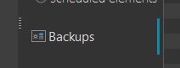

1. This opens the Backups internal window. Here, previous backups can be handled.

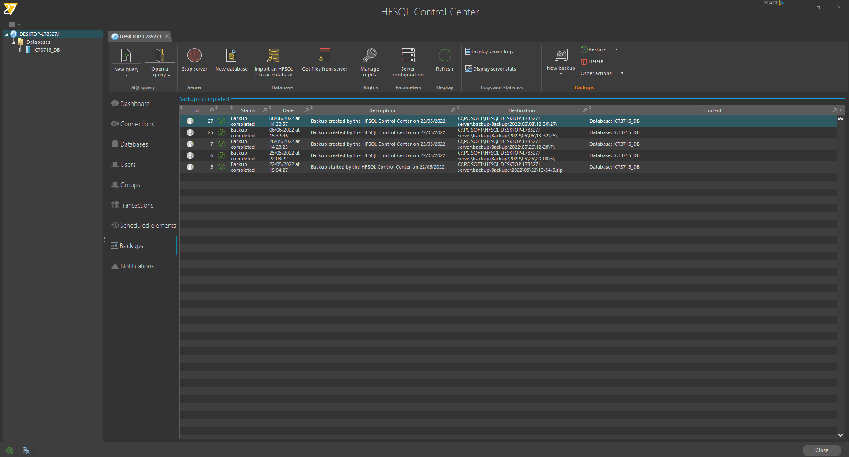

1. To create a backup, I select the New backup option.

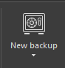

1. The Create Backup window is displayed. This is a hot backup, where a specific backup can be done. Scheduled backups are available, which I already implemented but this is a basic idea of how it is done. I use the hot backup as my main backup thus making sure it is performed especially before and after large changes. The hot backup window gives me different backup options, I will be making a specific database backup.

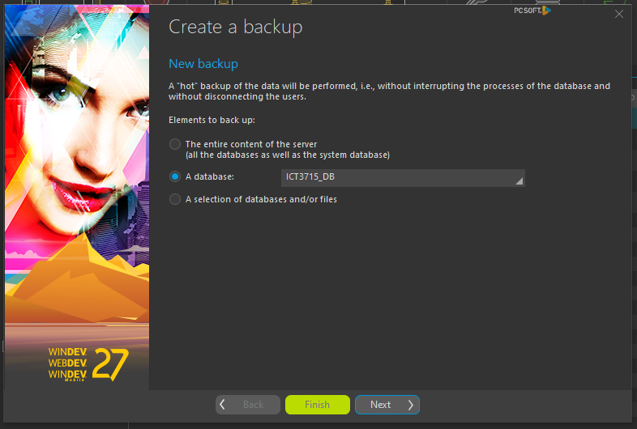

1. After selecting my database to back up, I can choose how the backup will be stored, I make use of the default settings.

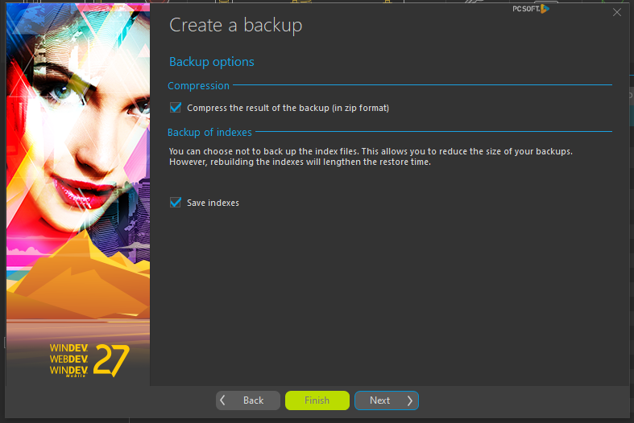

1. I select a directory where the backup will be saved. After the backup is done, I copy and paste the backup folder in different directories, one of which is my UNISA OneDrive file so there are multiple copies available to me, allowing me to be ready for any crashes that may occur. I also selected the date and time to be added to my backup file.

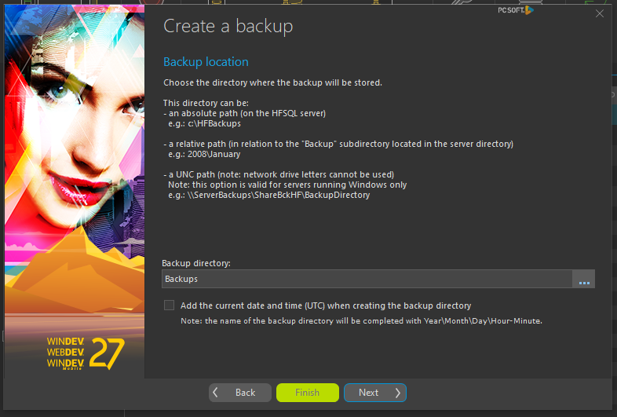

1. The following window allows for advanced additions to my backups. For my project, this is not necessary so I will move on.

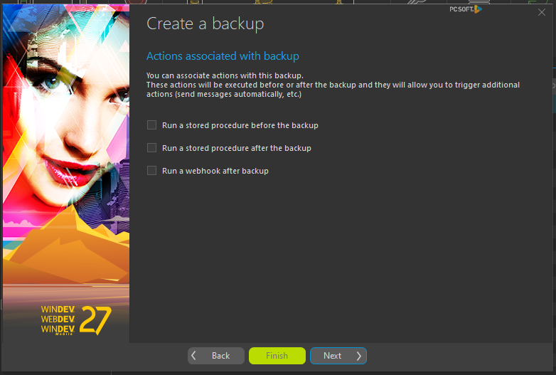

1. This window indicates the settings process is done and on Finish selected the backup will initiate.

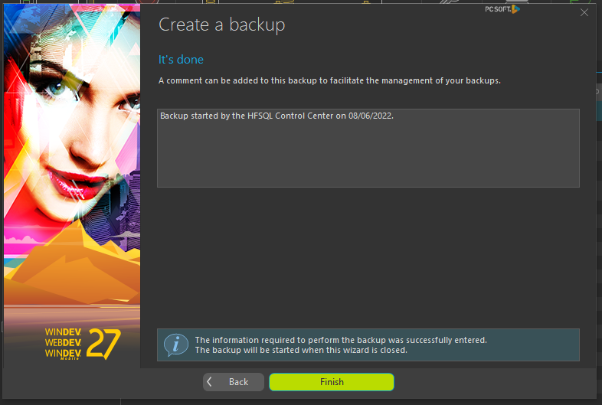

1. The backup starts and its progress can be viewed in the Backups window.

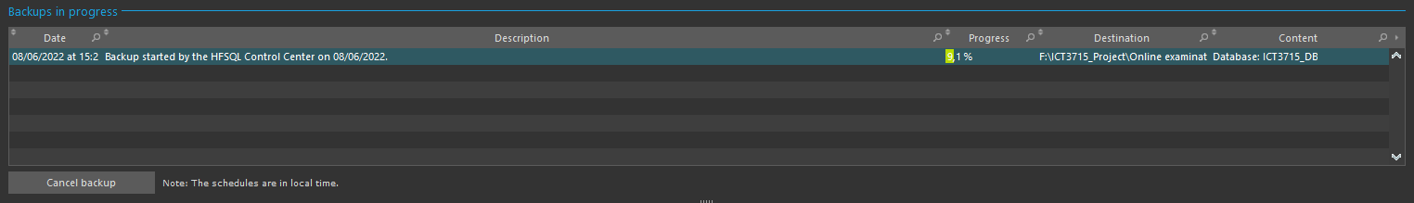

1. Once finished, the backup’s success can be viewed in the main panel.

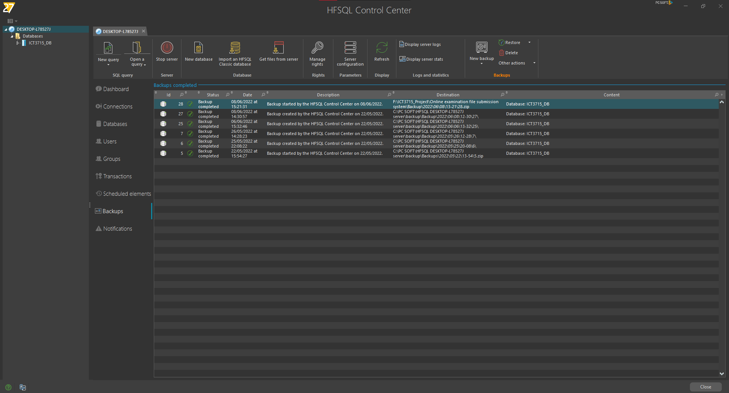

**Database Restore**

1. Restoring a backup can be done from the same window. Simply select the Restore Option and select a restore option, I will restore the backup I just made, It is already selected.

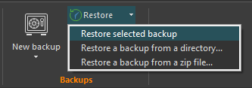

1. A popup window appears with some basic information regarding the restore. I have no active user connections so I can continue.

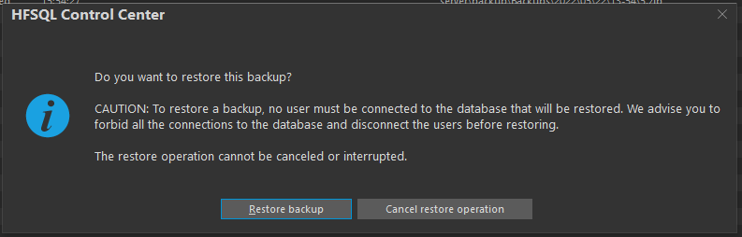

1. Once the Restore is done, a confirmation message is displayed.

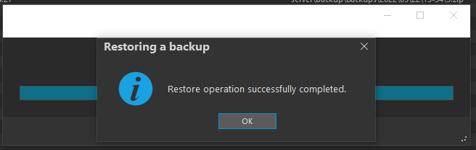

1. As I stated, I created a schedule backup for every day after I have worked on my database. The procedure described above is followed to do so with only the added option of setting the schedule.

### Programming code & Portfolio (assignments) (20)

I will do this with WEBDEV’s SCM (Source Code Manager). The SCM uses a repository that contains all the sources of my project: procedures, classes, windows, pages, reports, components, analyses, etc. The SCM allows me to manage the history of modifications and versions and allows me to work remotely as my SCM repository will be saved on a cloud server in HFSQL Client/Server mode. This will make backup and restore, simple and easy.

**Connecting to the SCM**

1. In the project SCM tab is the Add Project to SCM option.

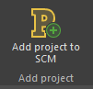

1. This option opens the repository window. To add my project to the remote repository, I selected the HFSQL Client/Server option.

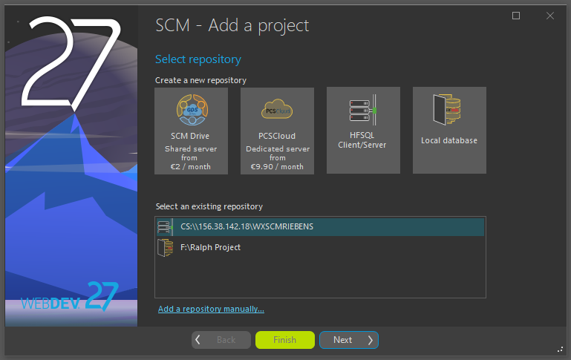

1. I then entered the details required to link my project to a new repository on a cloud server.

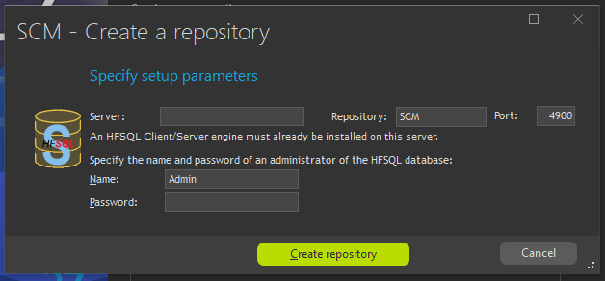

1. After connecting to the repository, I can add folders and subfolders where I can store multiple projects.

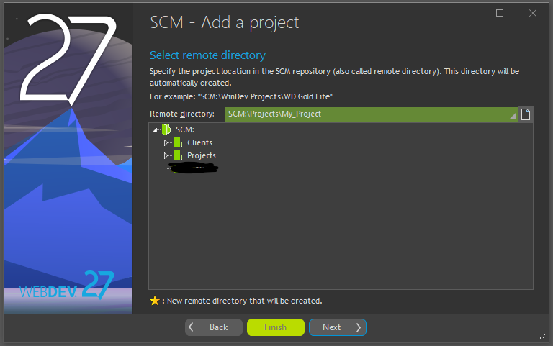

1. I select the elements of my project I want to add, in my case I added all of them.

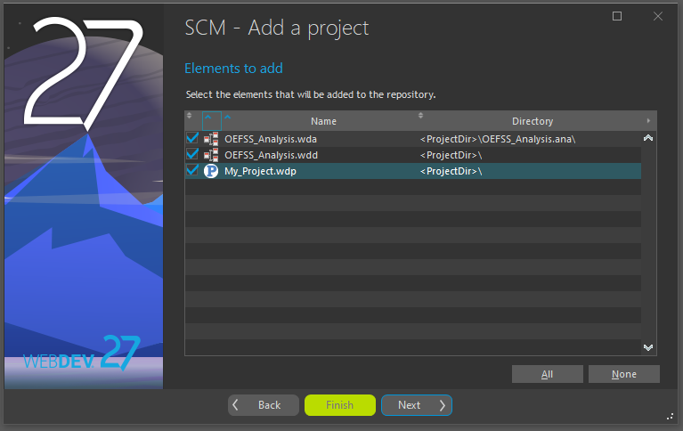

1. I select the dependencies of my project I want to add, in my case I added all of them.

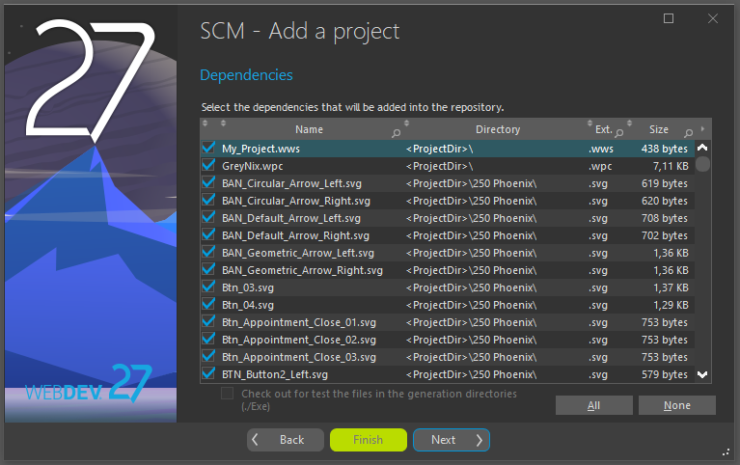

1. Then a final window finalizes my project addition to the repository.

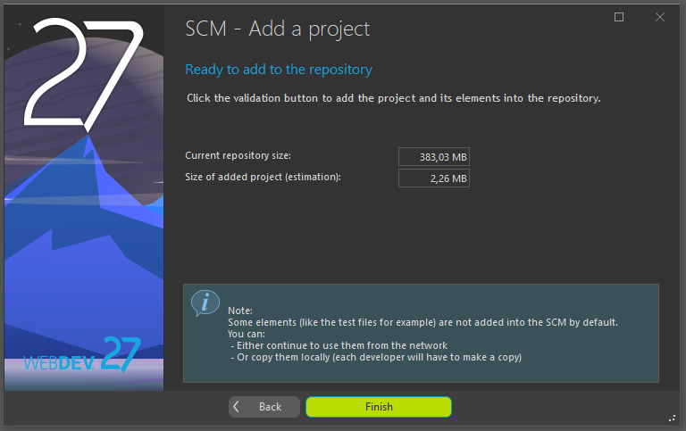

1. After my project was successfully added, the following toolbar appears that allows me to retrieve, change, delete, update and check my project history.

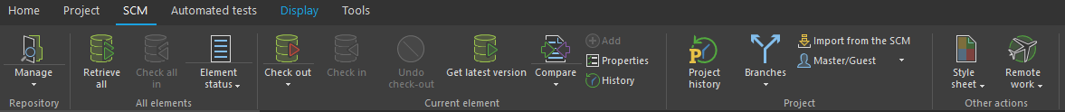

1. The Check out option allows me to retrieve, for example, the Login page, change some code and check the element back in to the repository with the Check in option.

 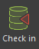

1. The Check out window allows for multiple options of check out, I keep the default value and continue.

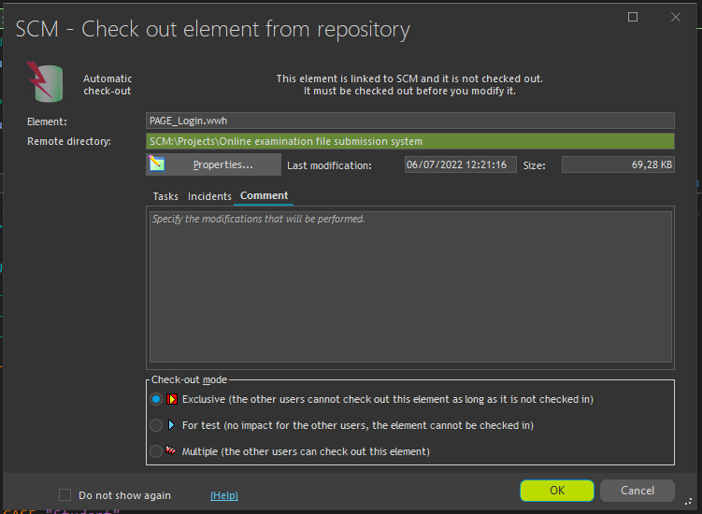

1. To view my project history, I can select the Project History option.



1. This option allows me to view, compare, and retrieve previous versions and changes made for when, for example, I have made a grave mistake and want to revert back to a previous save.

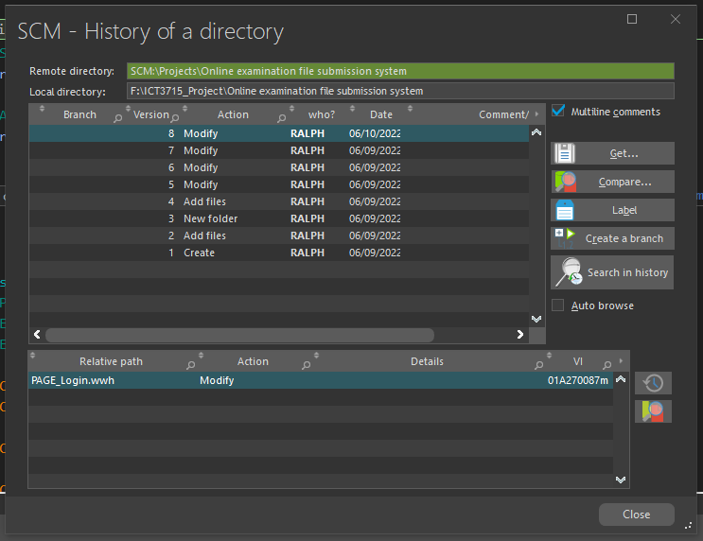

The SCM allows me to handle my project remotely from anywhere and have access to previous versions and element modifications that allows for easy restore. It’s basically an auto project backup system that also keeps my project safe and ready for me to restore anything, anytime.

# Assignment 1

## Section A [4]

### Programming Languages (2)

**WLanguage**

A powerful 5th Generation language that will allow me to meet all the requirements stipulated by the project.

The project will be built using **WLanguage** in the **WEBDEV** development environment.

(Special permission was granted by Module Leader, Ina Scholtz. Please see email at end of document.)

### Database (2)

**HFSQL**

WEBDEV's official database.

(Special permission was granted by Module Leader, Ina Scholtz. Please see email at end of document.)

## Section B [10]

### Cleaning the data

(Cleaned and attached .csv file to the end of my assignment as PDF)

## Section C [10]

### Activity Diagram (7)

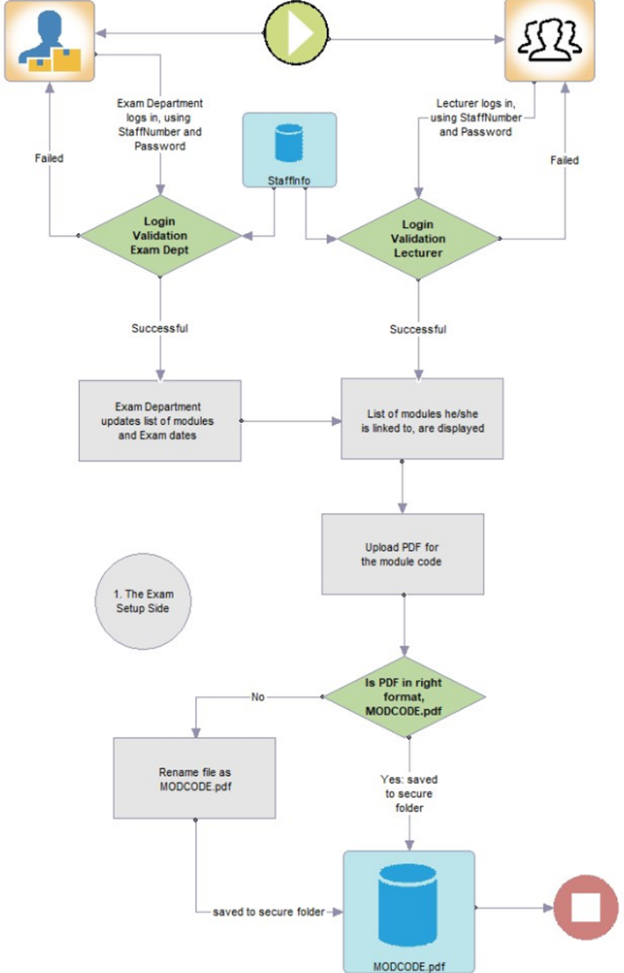

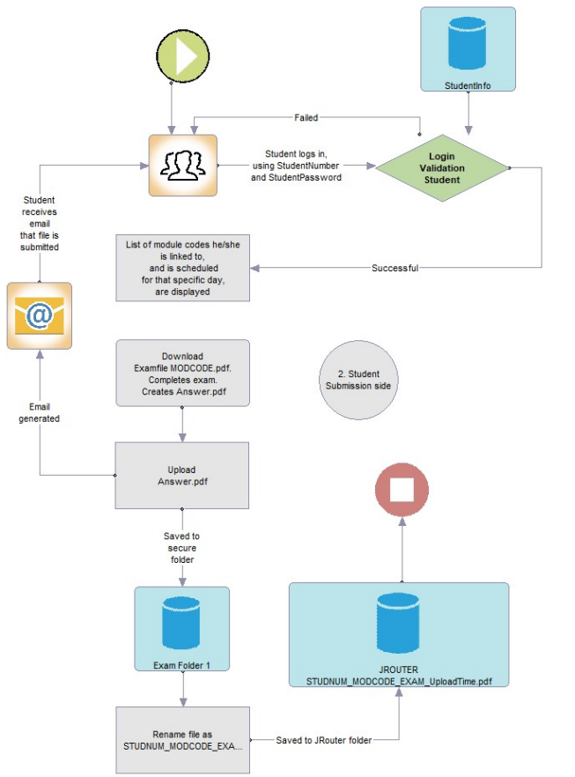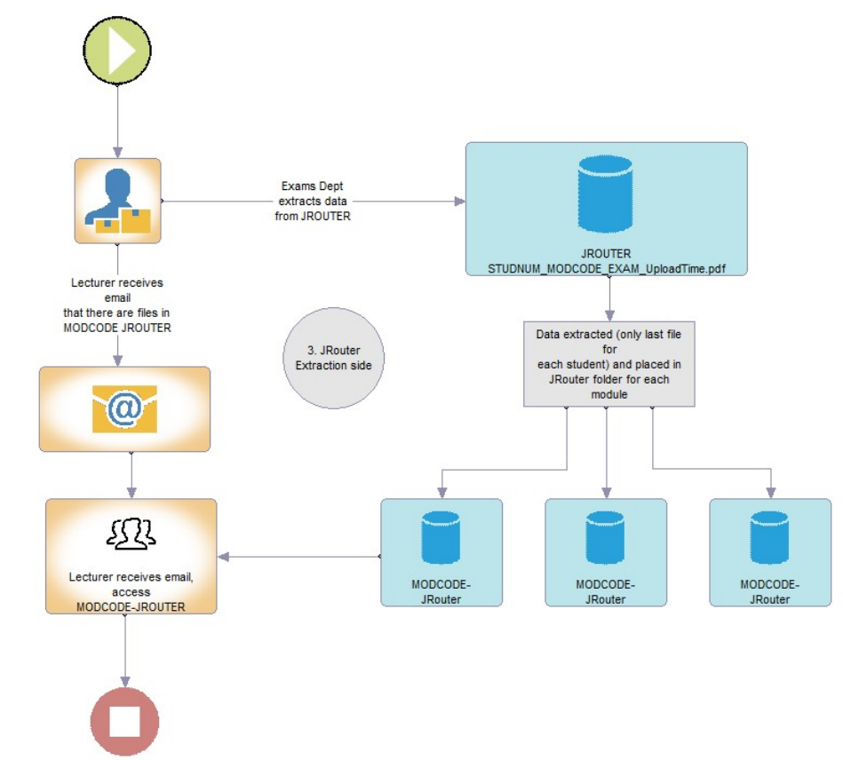

### ERD Diagram (3)

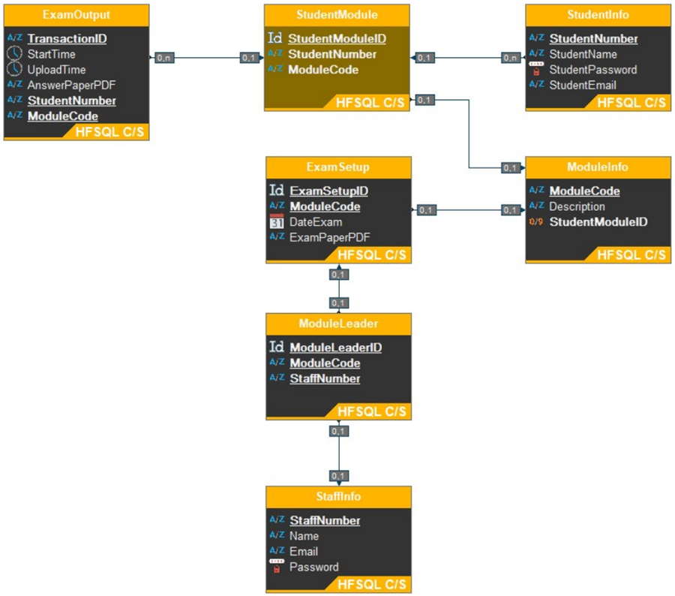

## Section Backup and Recovery for the Database and Programming code [6]

### Backup and Recovery Software for the Database (3)

• WEBDEV HFSQL Control Centre, allows for easy Database backup and recovery on the custom server in HFSQL Client/Server mode that I plan on using to also store my project which will also allow me to work on my project remotely.

• Make a separate backup of the Database and save it in OneDrive. WEBDEV makes it possible to restore an entire Database with ease this way.

### Backup and Recovery process for the Programming code and your Portfolio (assignments) (3)

• WEBDEV’s SCM (Source Code Manager). The SCM uses a repository that contains all the sources of my project: procedures, classes, windows, pages, reports, components, analyses, etc. The SCM allows me to manage the history of modifications and versions and allows me to work remotely as my SCM repository will be saved on a custom server in HFSQL Client/Server mode. This will make backup and restore, simple and easy.

• Make a separate backup of the Project and save it in OneDrive. WEBDEV makes it possible to restore an entire Project with ease this way.

# Module Leader Approval

## Graphical user interface, text, application, email Description automatically generatedRequest

## Approval

